# Weekly Binder Credit Management Report

**Overview sheet for the weekly Reporting for binder credit management**

The report is separated into four different reporting areas:

* Nil Signed Binders Report (FDO not Received and FDO received)
* Using Deman reporting (No FDO report for Binder (All Brokers) and Nil signed Binder report)
* Overdue Risk bordereaux Report
* Overdue Debt Weekly Report
* Unpaid Bordereaux Months Report

The whole report which consists of the four reports above is sent on the first working day of the week to a selected number of people and all four reports should be completed all at once and sent as one report.

* Before starting open the last week’s report from **S:\Rclarkson\Reporting Spreadsheets\New Reporting Folder\Weekly reporting**

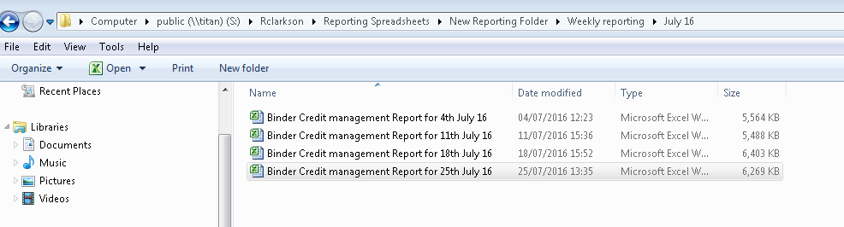

* Save as a new report, with current date, in the same drive/folder.

**Nil Signed Binders report**

This report is used to identify the Binders where no signings have been received (There may be FDO signings present, but no premium has been signed or we are still awaiting the FDO signings).

* Create a new sheet (Tab) in the existing report & save exported data to this new sheet. There is no need to name this new tab.
* There are 2 exported data
* Do not save the “header” row when copying the 2nd export over to the new sheet.
* Refer below screen shot for reference [copy the data of 2nd extract from **Row 2 to** **last row** and paste to the **last line of data** of that sheet.

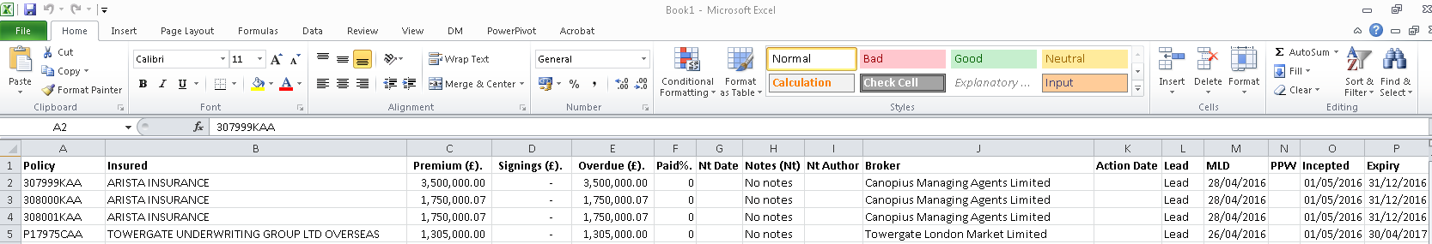

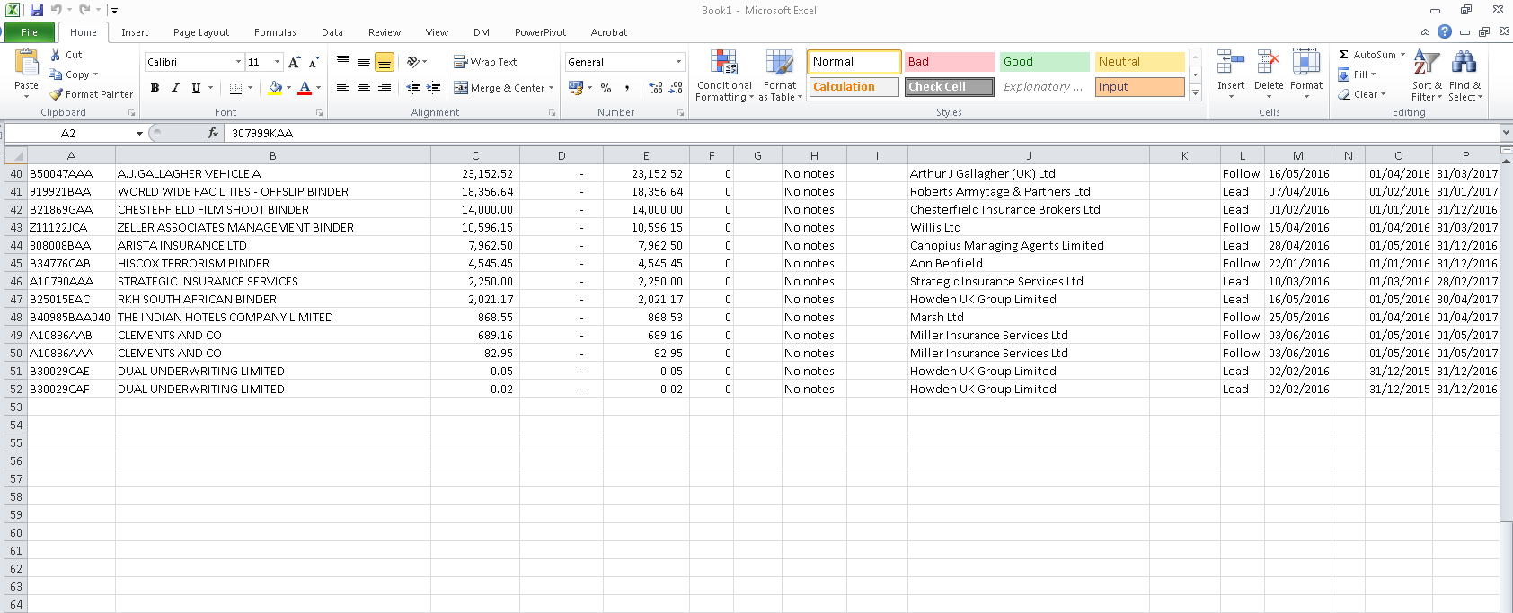

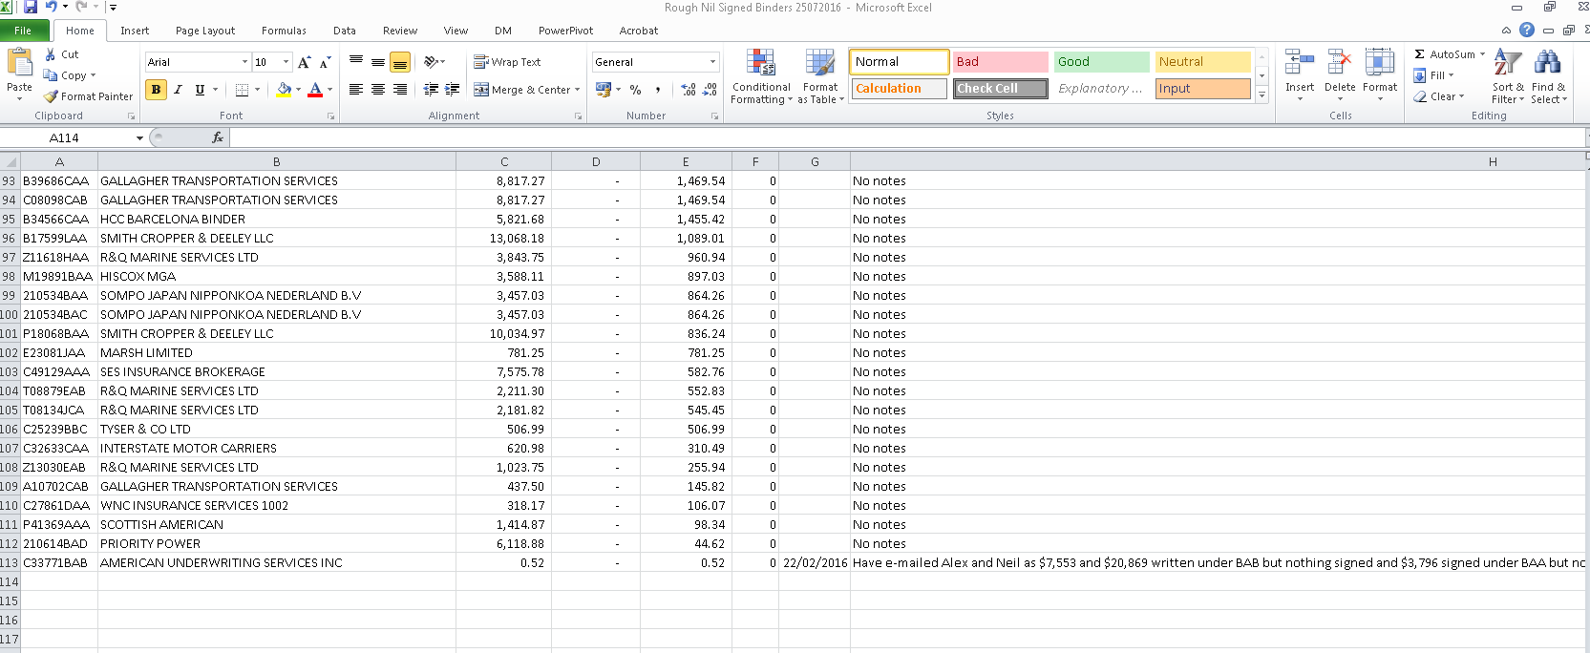

To Format the data in the new sheet:

* Adjust all the columns to fit data & adjust the width of column **H** to 15.
* Cut paste column **AN** & insert before column **A**. (Do not paste it)
* In column **A**, replace **“False”** with **“FDO Not Received”** & “**True**” with **“FDO Received”**.
* Insert three columns to right of column **“S”** **(i.e. from Incepted)** & then copy the headings & the formulas for **“Aged Months + Rounded + Age Period”** from the Nil Signed Binders tab in the existing report i.e. Colum **“T + U + V”**. *(Note that the column should be formatted as General)*.

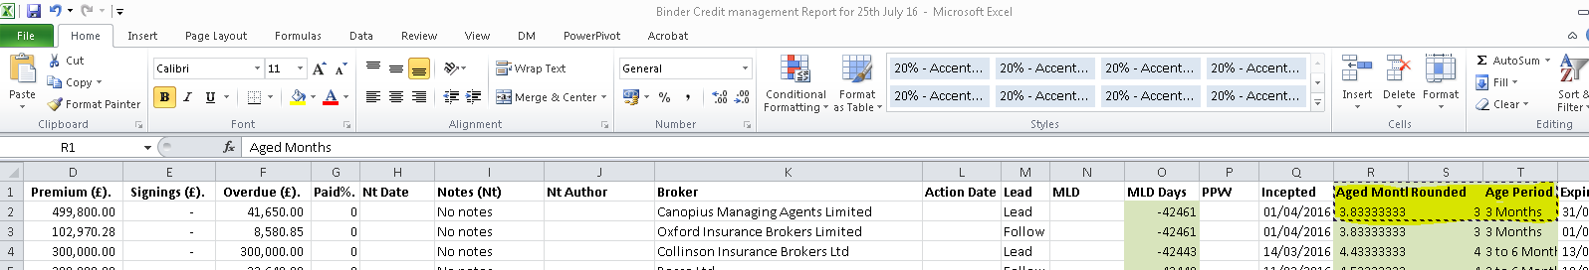

* Now paste the formula in the new sheet where you have inserted **three Column’s** :

(Formula should be **pasted via tool bar button click**)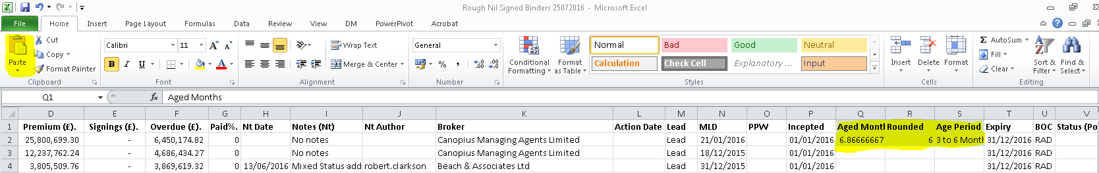

* Check that the formulas have been copied as formulas & not as text, then copy the formulas down by double click.
* Add filter & select FDO Received from Column A (**FDO Signings)** then remove any lines under the "FDO received" where column D (Premium (£) is showing less than 1 unit as this indicates nothing due and e-mail Binder Credit Manager the details of which ones have been removed.

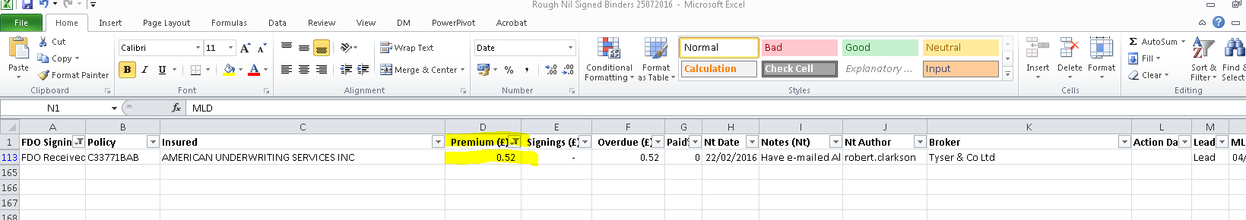

* Remove all lines relating to "Aon Client treaty" ,"S&P Underwriting" (I08018BAA/BAD) or Willis Crest Facility W53690AAA/B/C/D under column **C** if there are any lines for these clients as these are consortiums and therefore we will not receive any FDO signings.
* Remove any lines where column E does have **signed premiums** in, as this indicates that FDO signings are elsewhere. E-mail Binder Credit Manager the details of the lines taken out at this point.

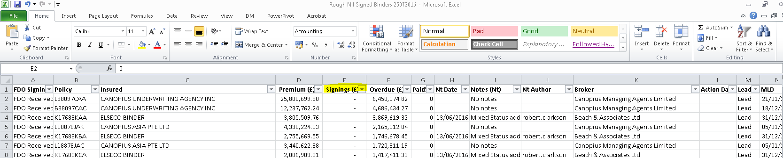

* Delete any line showing **"DECLAR**" or other than **Binder** under column AL **(Status)** :

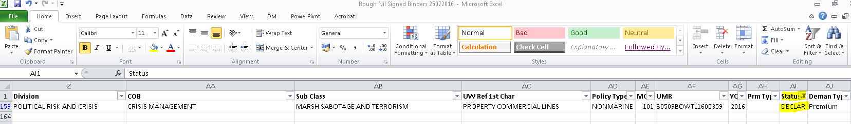

* Data is ready now, so delete existing Data under "Nil Signed Binders" tab and Copy new sheet into Nil Signed Binder tab, take off any filters before copying across.

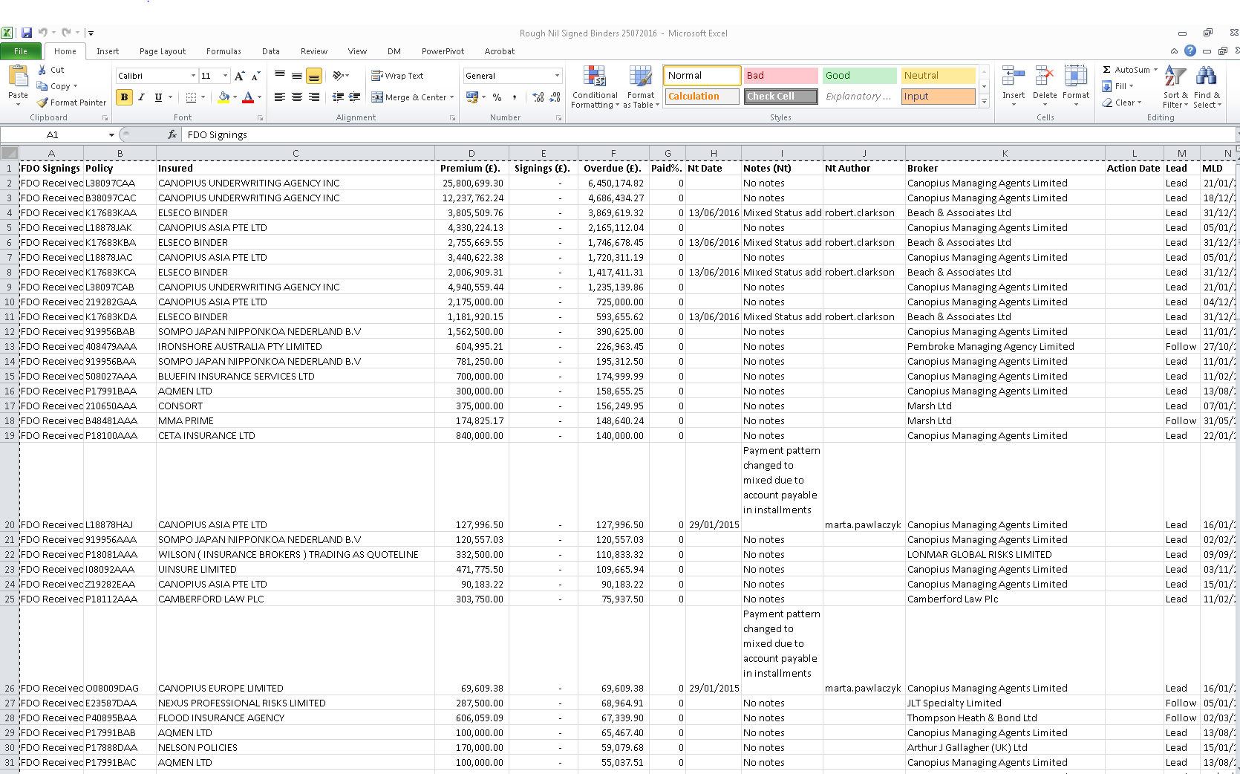

Note that whole sheet should be copied & pasted on the last file on the tab which is created as **"Nil Signed Binders”**. Once this is done we need to update the Pivot tables to pull up the changed data source.

* After copying & pasting the data, go to **"Unsigned Binders"** tab of the report, right click on **Division Slicer,** click on Pivot table connections & uncheck **all four Pivot table connections** (PivotTable11, PivotTable8, PivotTable2 & PivotTable7) Below screen shot shows it in two steps of how to do it for Division.

1. Right click on Division Slicer & click on **PivotTable Connections**

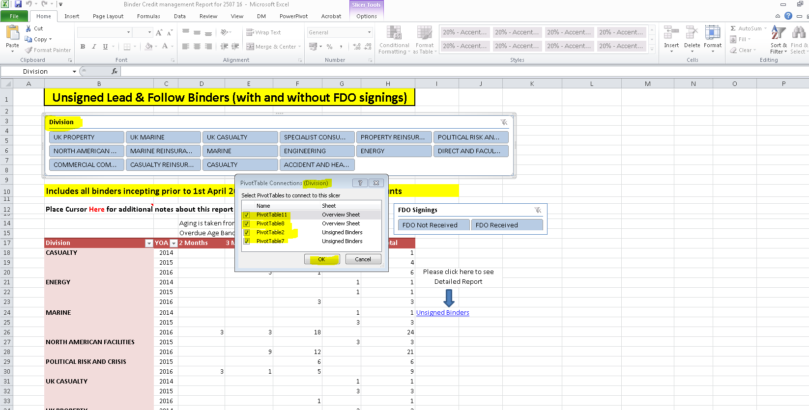

1. Remove the ticks from **PivotTable11, PivotTable8, PivotTable2 & PivotTable7** and click OK.

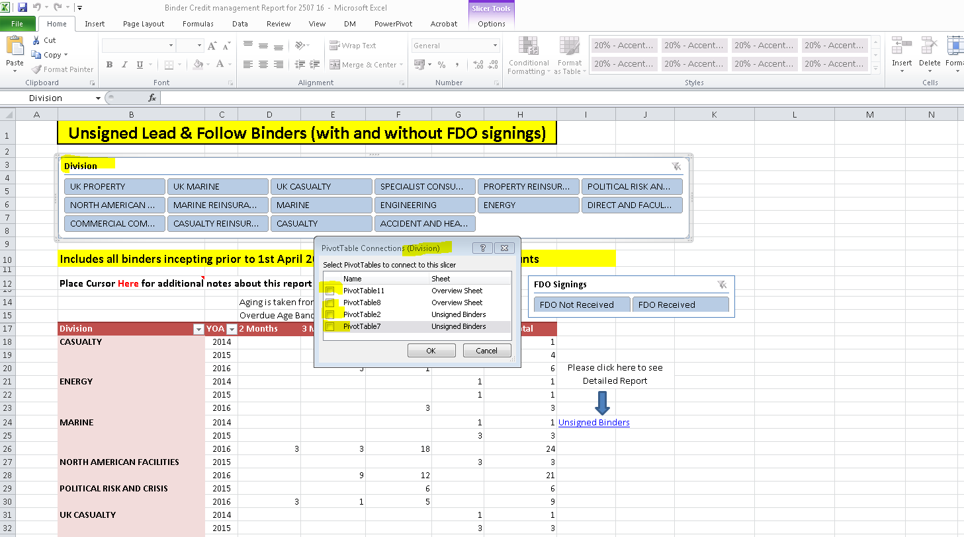

* Perform the same action for **FDO Signings** to take off **all four Pivot table connections** (PivotTable11, PivotTable8, PivotTable2 & PivotTable7) **:**

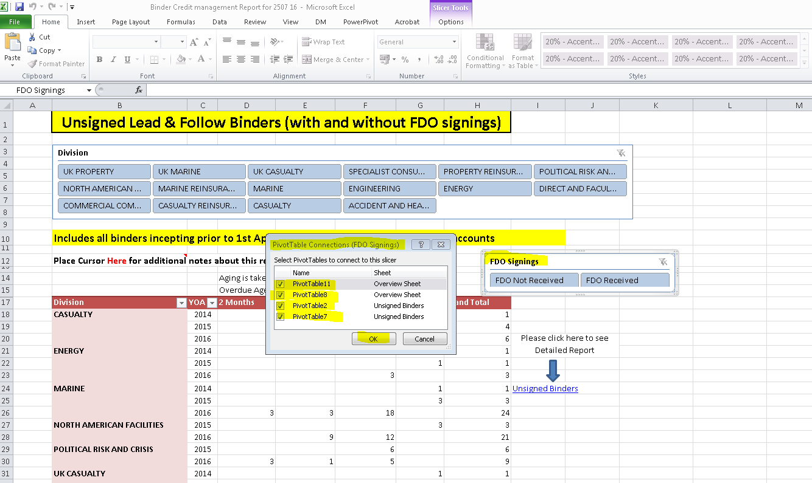

* Now click on **Unsigned Binder** :

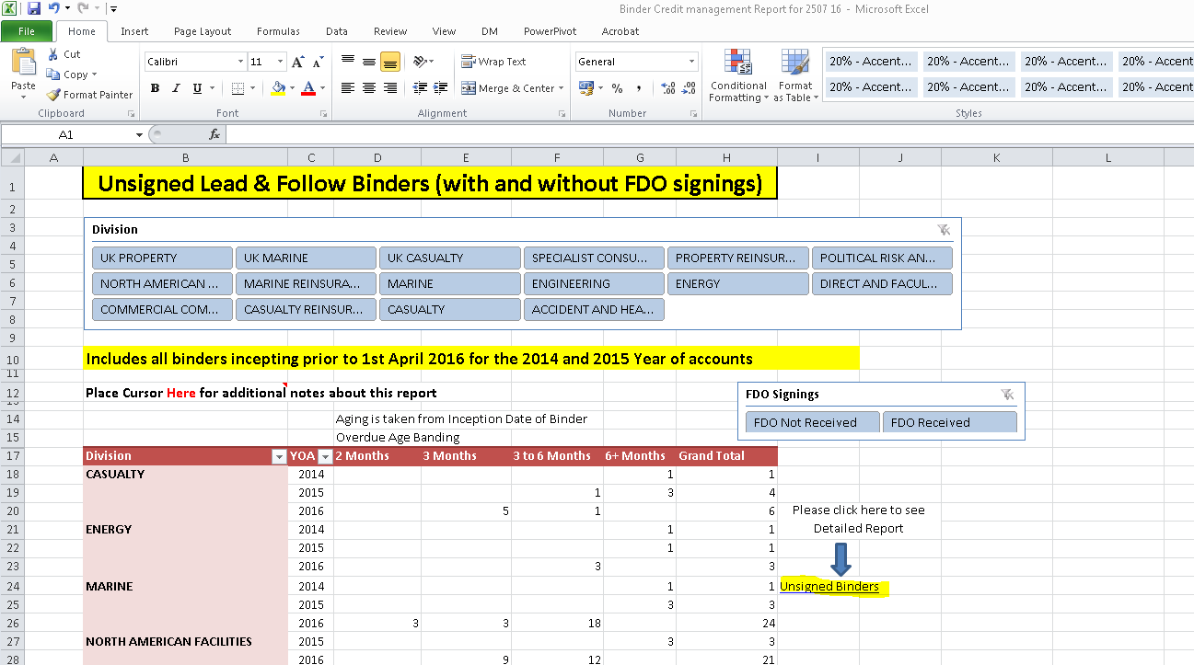

* Perform same action to take off all Pivot Connection for **Sub Class** (PivotTable11, PivotTable8, PivotTable2 & PivotTable7)**:**

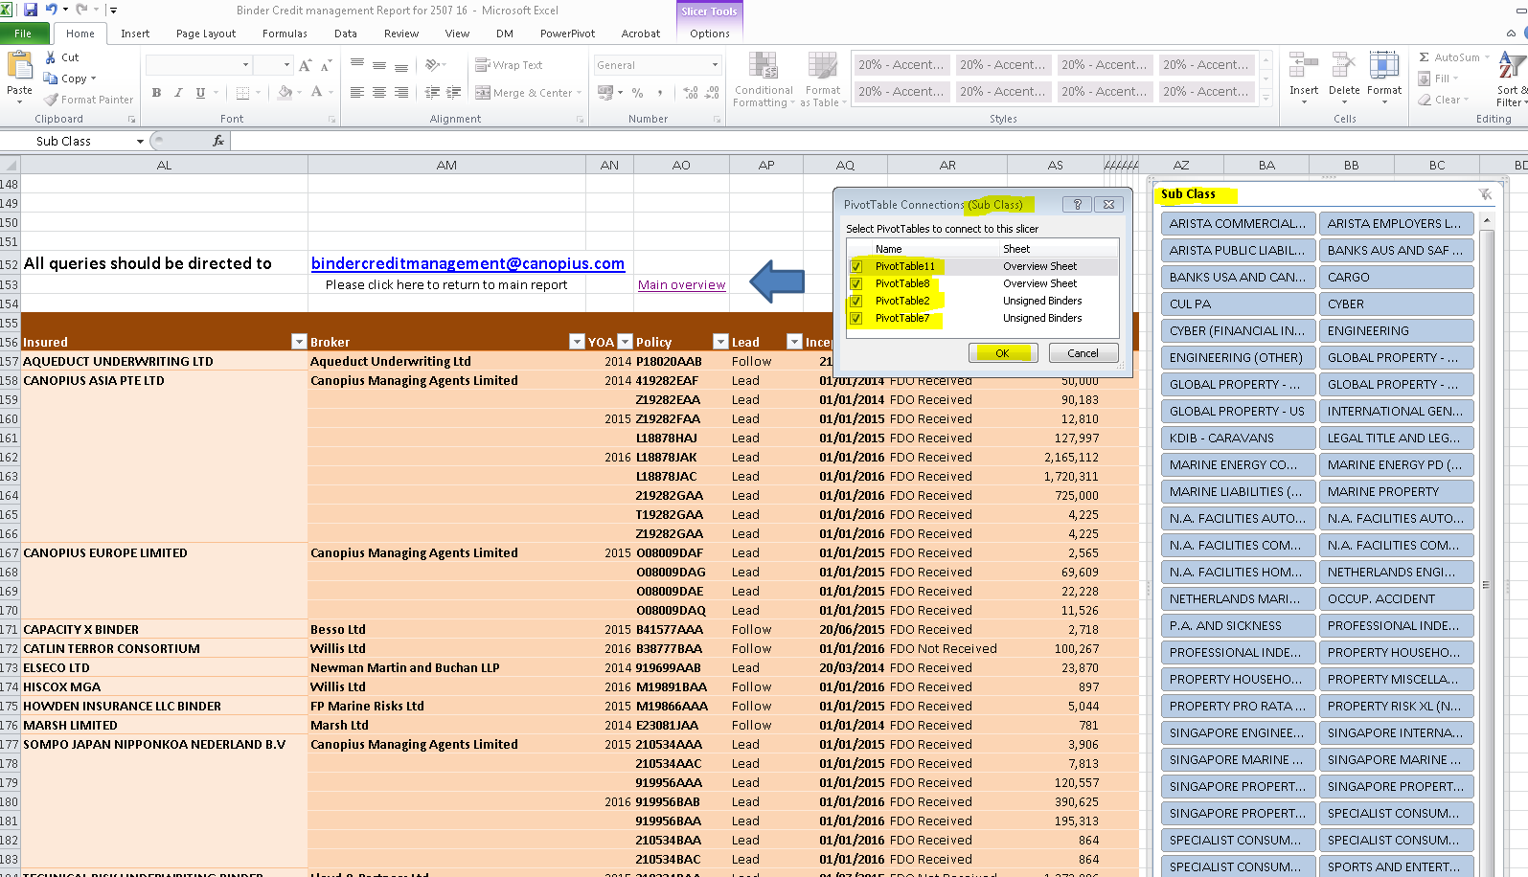

* Click on “Main Overview” to go back to main screen
* Now click on anywhere on **Division Pivot** then click on **Change Data source under Options**& then again click on **Change Data Source** :

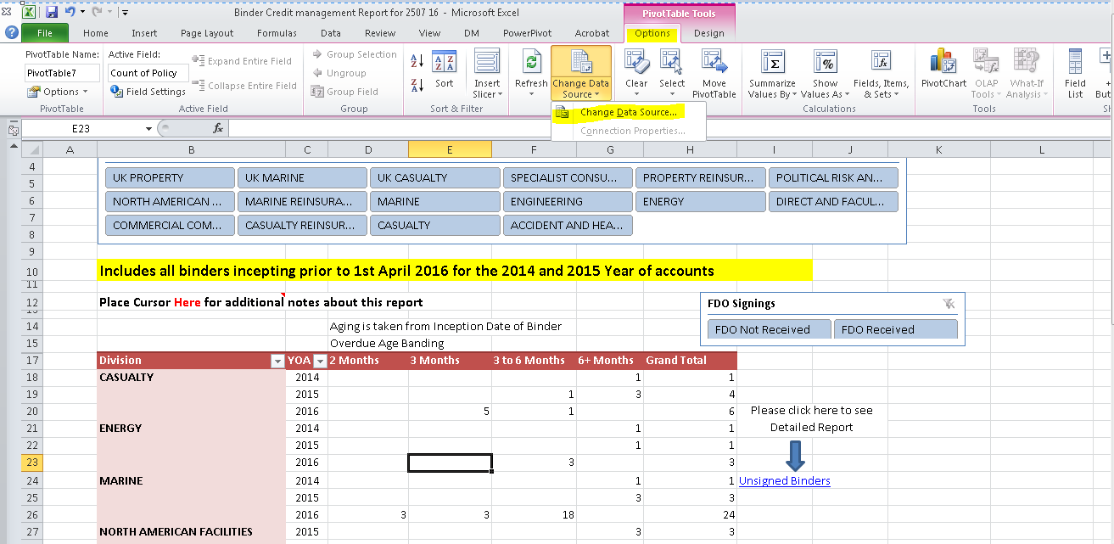

* Now Click on **A1** then Ctrl+Shift then **right arrow key**, **down arrow key** & then **OK** (To select a **data range** for Pivot)**:**

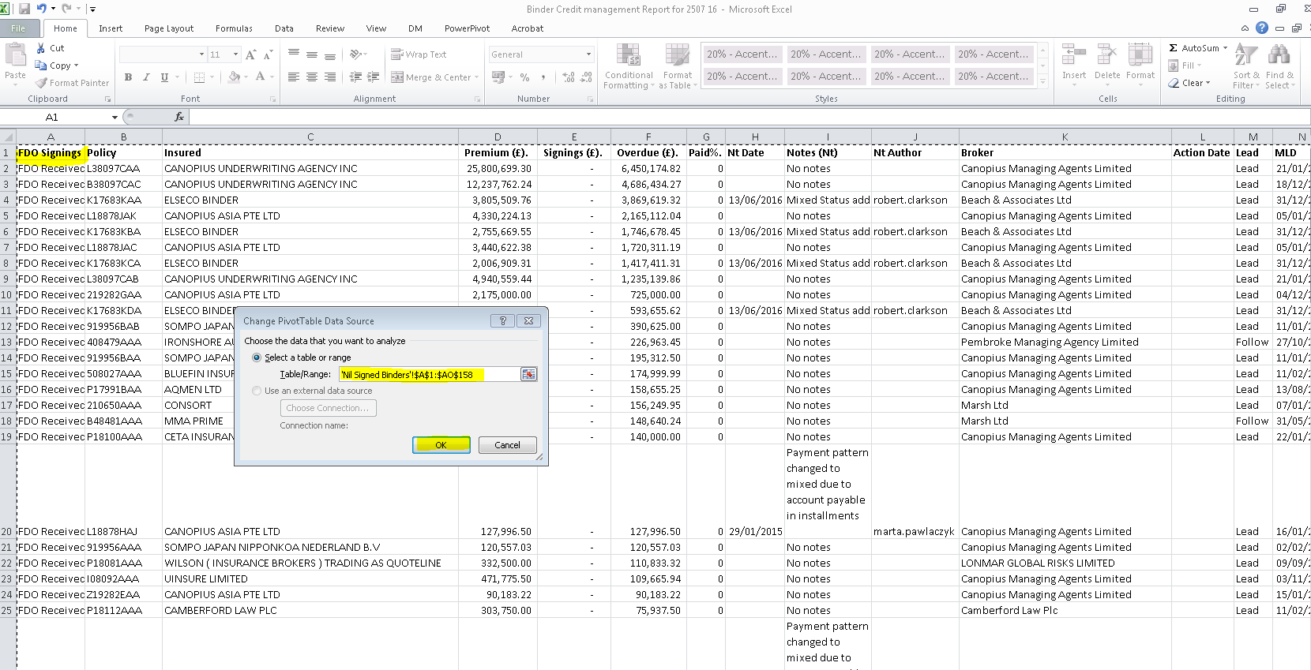

* Once the data source is changed then click on **Refresh** (which is there on toolbar) to refresh the pivot :

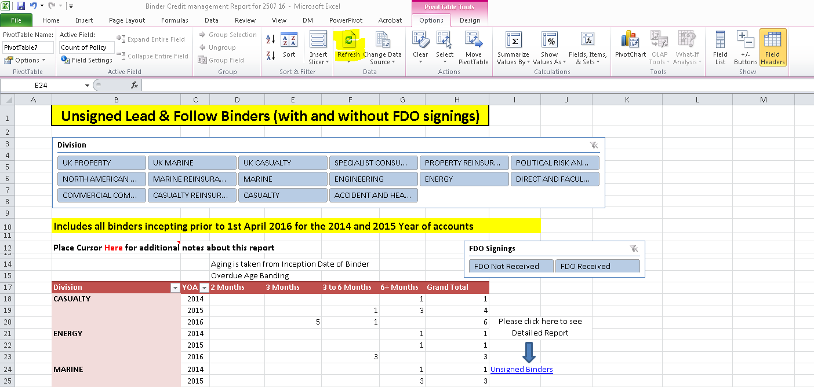

* Click on **Unsigned Binders**.
* Perform the same action on **Sub Class Pivot** to change the data source & refresh the data of Pivot :

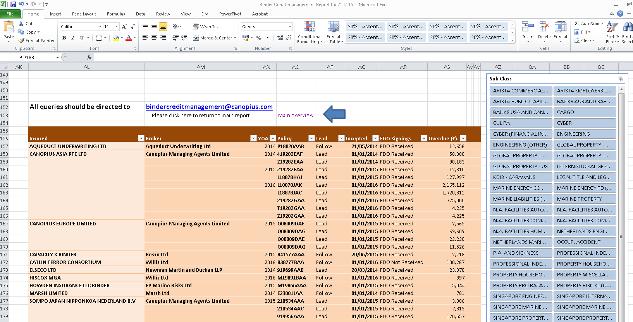

* Click on “Main Overview” to go back to main screen
* Now go to Overview Sheet tab and perform the same action to update the pivot tables on **Criteria Chosen Pivot** & **Unsigned Binder Overview.**

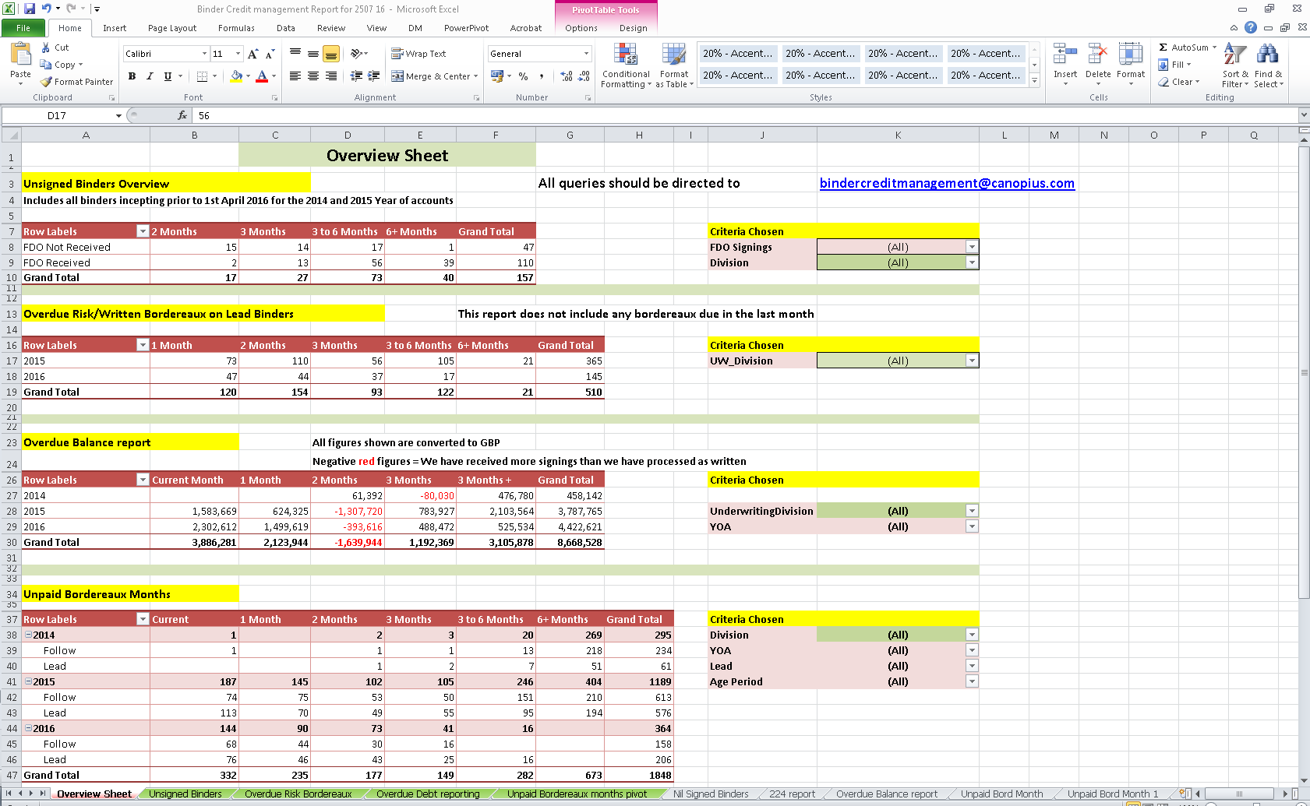

* After updating all pivot tables, click back onto the Unsigned Binders Tab and reconnect all the slicing tools by right clicking on each slicer table (Division, FDO Signings & Sub Class) and reconnecting the four pivot tables.

**Overdue Risk Bordereaux**

RS224 Report from Cnet

This report is run from C-NET for all Lead contracts, to highlight the months where we have had no written figures processed into Subscribe.

* Adjust all columns to fit data & delete **top three** Rows.

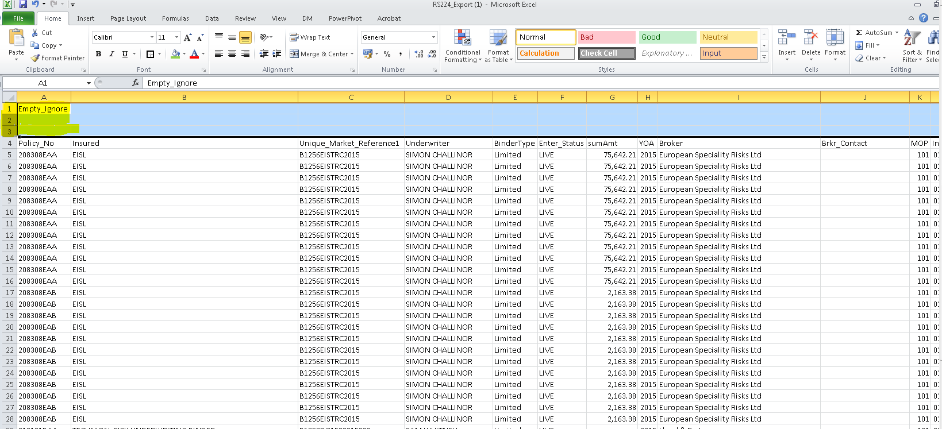

* Apply filters & delete any **Partial, NTU or Cancelled policies** in **Column F (Enter_Status)** :

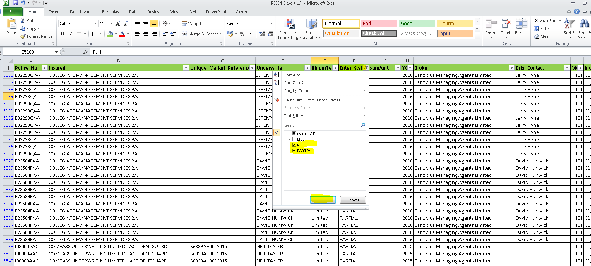

* Delete all MOP codes **100 & 110** from column K & keep **MOP** **101** only.

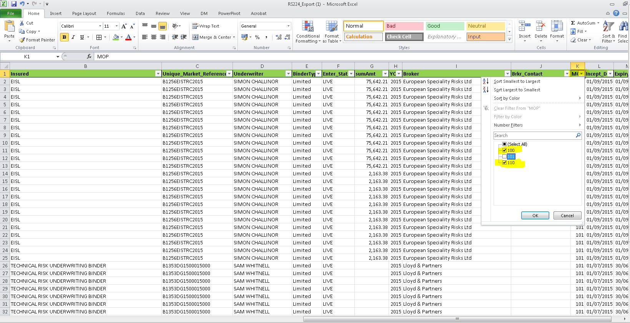

* Delete all due dates that **become due after the start of the previous month** from **Colum X (Bord_Due_Dt).**
* ***If we have anything blank in “X” column which is due prior to start date of previous month then we need to report it to the Binder Credit Manager.***

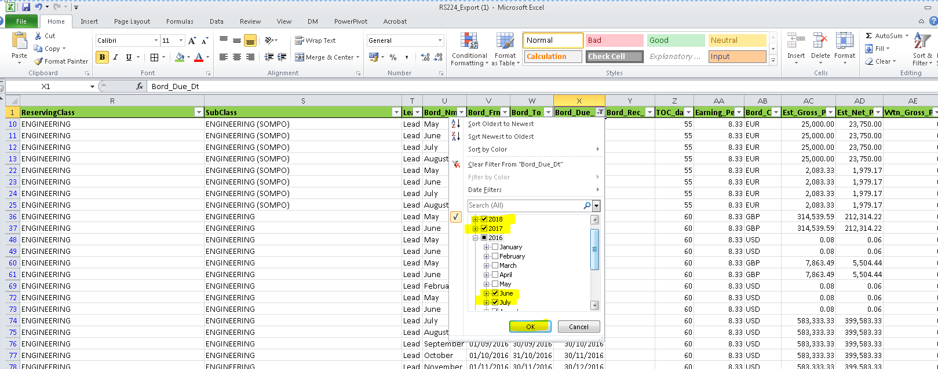

* Delete all the rows which have **dates** in column **Y (Bord_Rec_Dt)**:

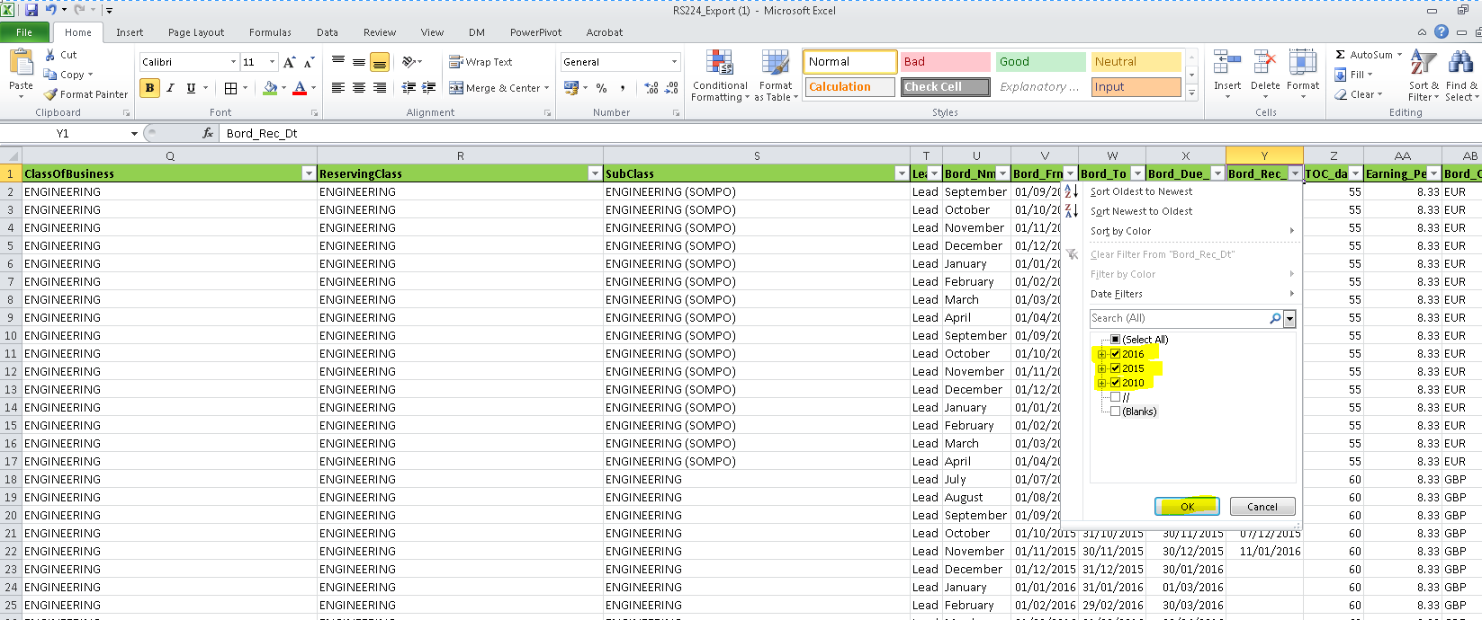

* Delete all **Est Net prm** (Column AD) items less than 100 (Column AD) [Apply a filter & click on less than 100 & OK]:

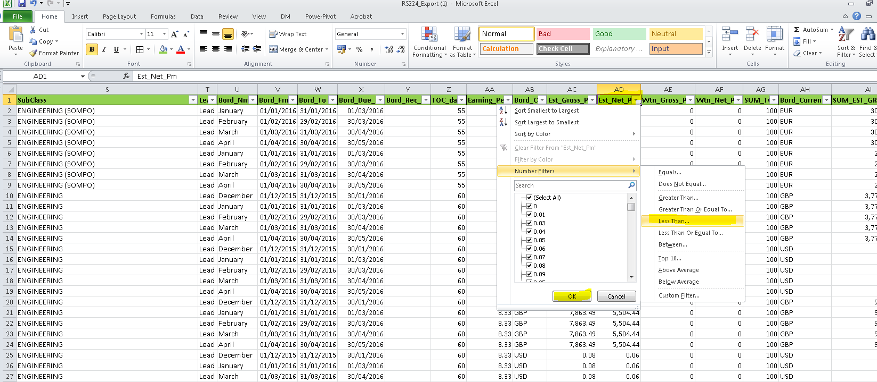

* Delete **Canopius Asia Pte Ltd, Breckenridge Ins Services LLC, Tapco** **Underwriters Inc**, **Theodore Tunick & Marshall & Sterling, Fairway Insurance Services Inc Binder,** **Theodore Tunick & Co & Marshall & Strling Ins from Column** **“B”**.

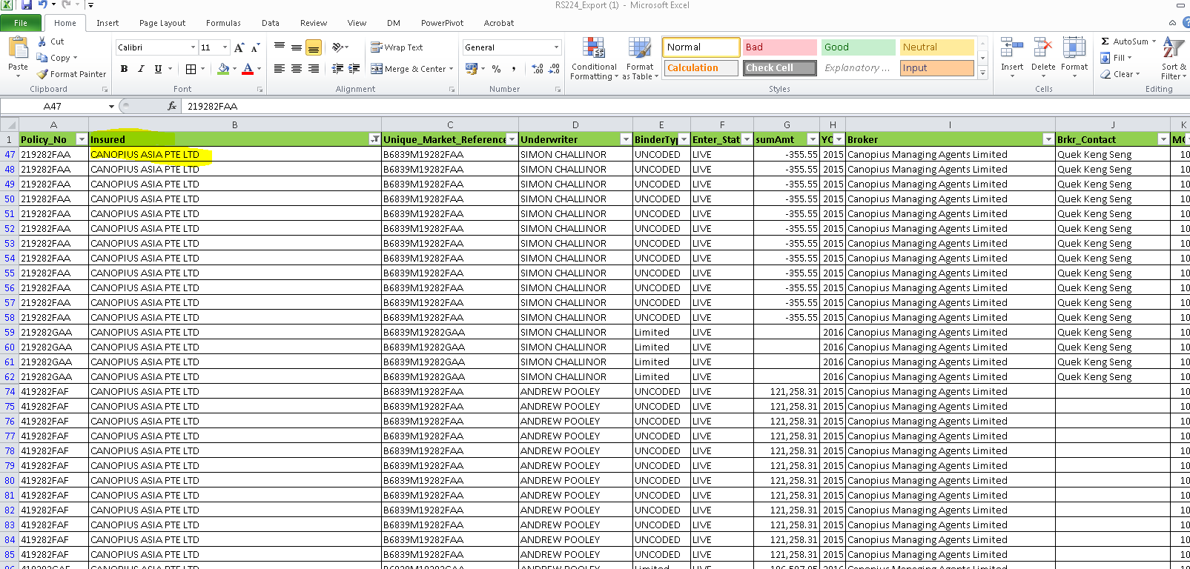

* After this delete all those rows where the **Net Written Pm** is not Zero in Colum **“AF”** (i.e. **8,360.00 will be deleted in below case**): This is because if something has been entered then we must have received a risk/written bordereaux.

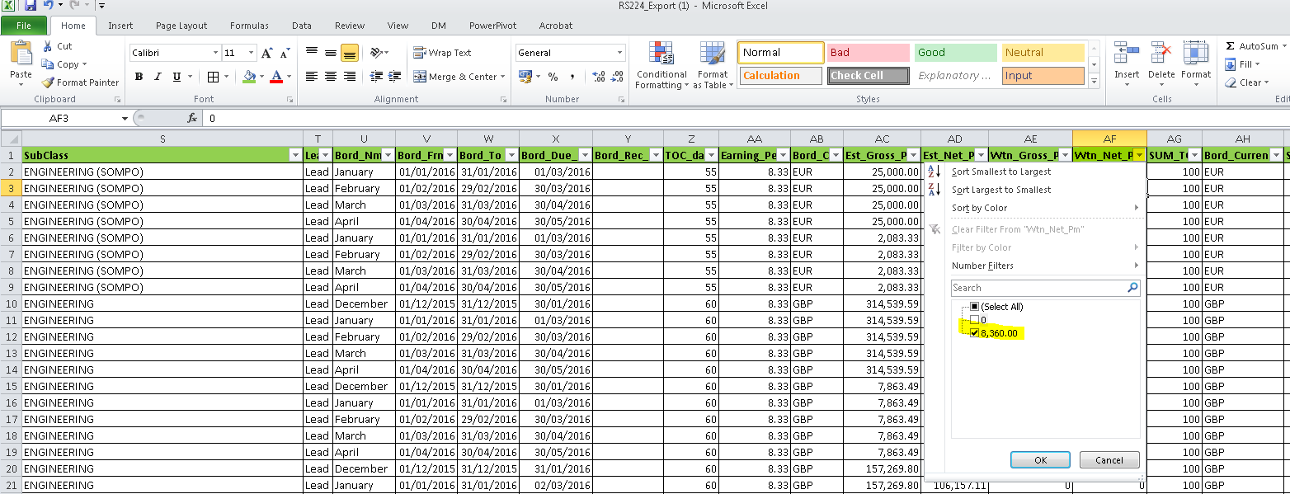

* Insert three Columns to the right of column **X** i.e. **Bord_Due_Dt**

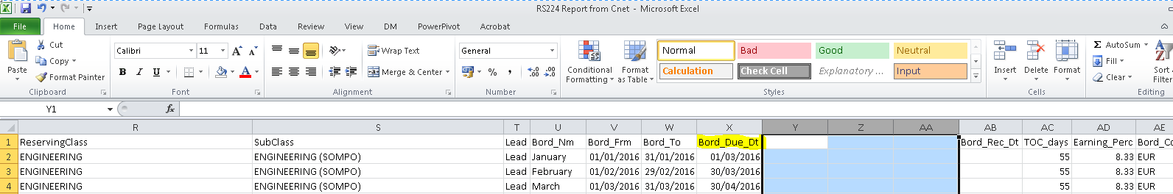

* Now copy the formulas for **“Aged Months + Rounded + Age Period”** from **existing report tab** i.e. Colum **“Y + Z + AA”**. *(Note that the formula should be copied by right click)*.

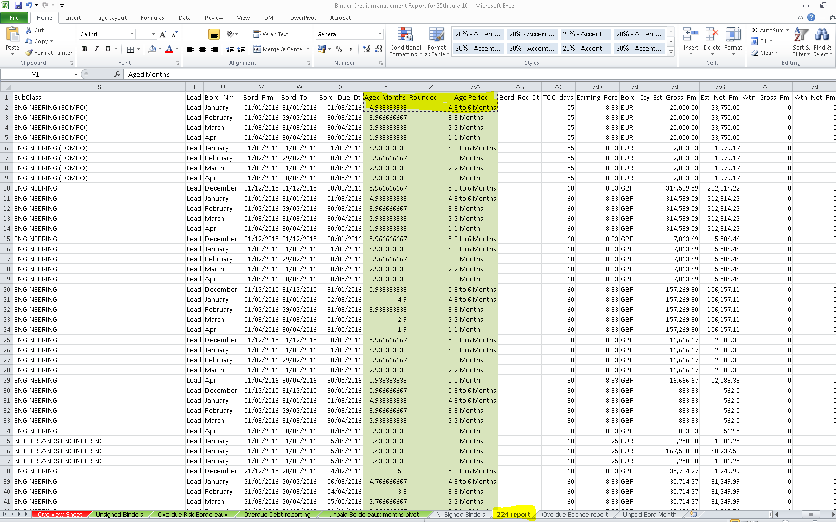

* Now paste the formulas in **new extract** where you have inserted **three Columns** :

(Formula should be **pasted via tool bar button click**), click on each cell to check that the formula is shown and it has not converted to Text.

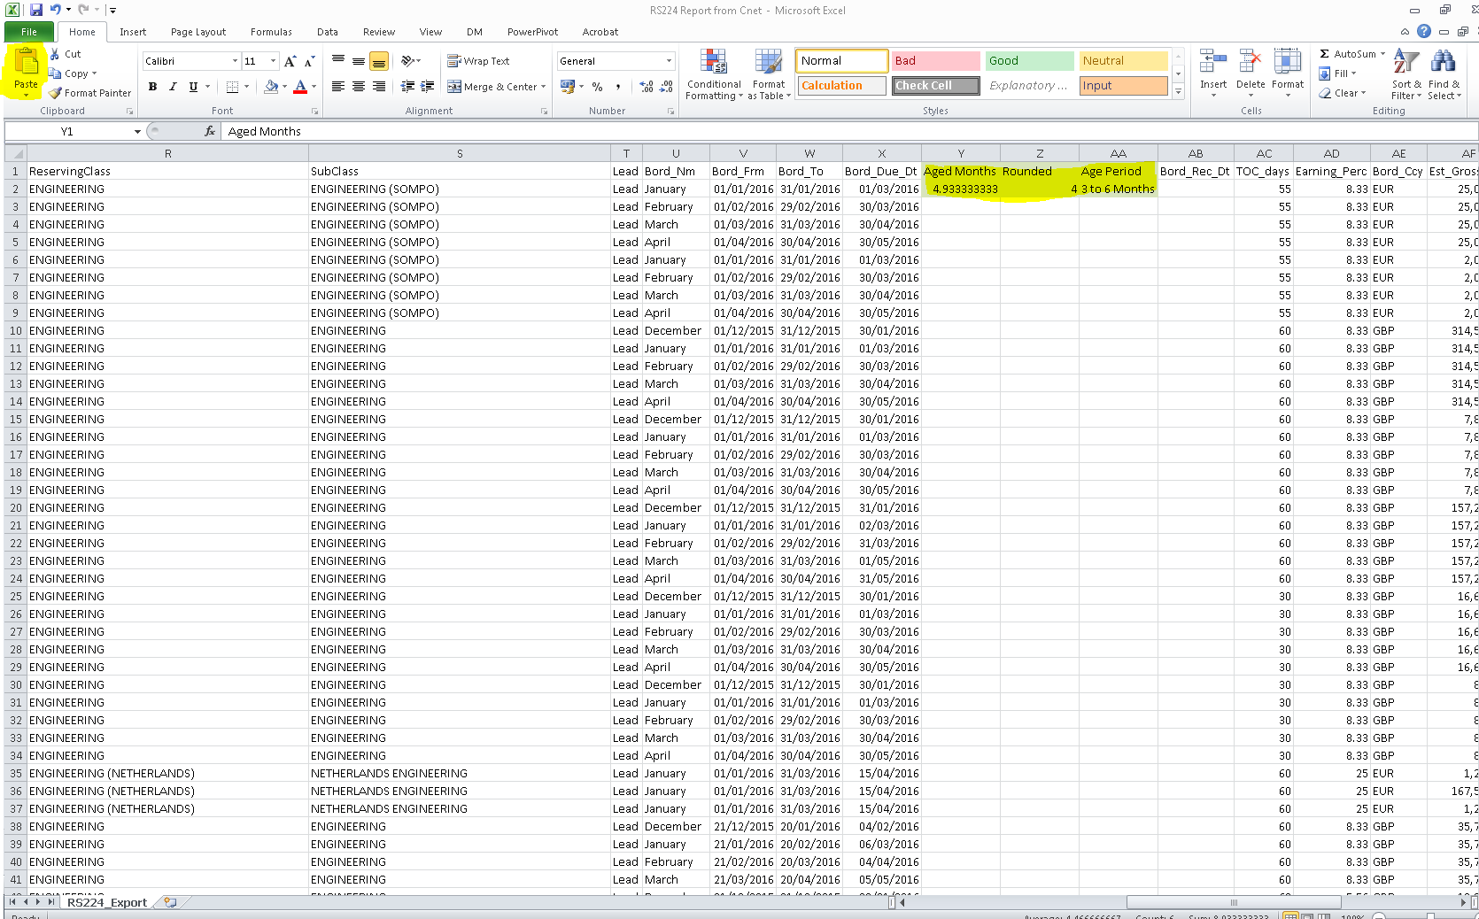

* Copy the formulas down by double click.

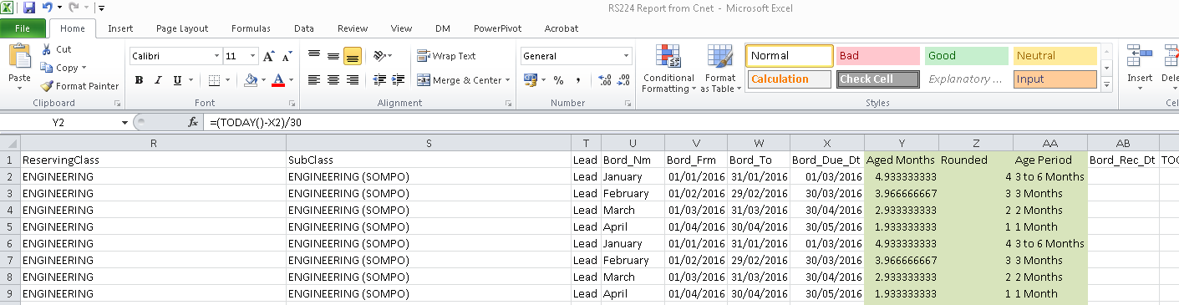

* Delete the existing data under the “Overdue Risk Bordereaux” tab.
* Remove the filters & now copy & paste the new sheet to the 224 report sheet in the **existing report.**
* Delete the tab used to put this report together and where you have just copied the data from.
* Go to **“Overdue Risk Bordereaux”** to Disconnect the Slicing tools :

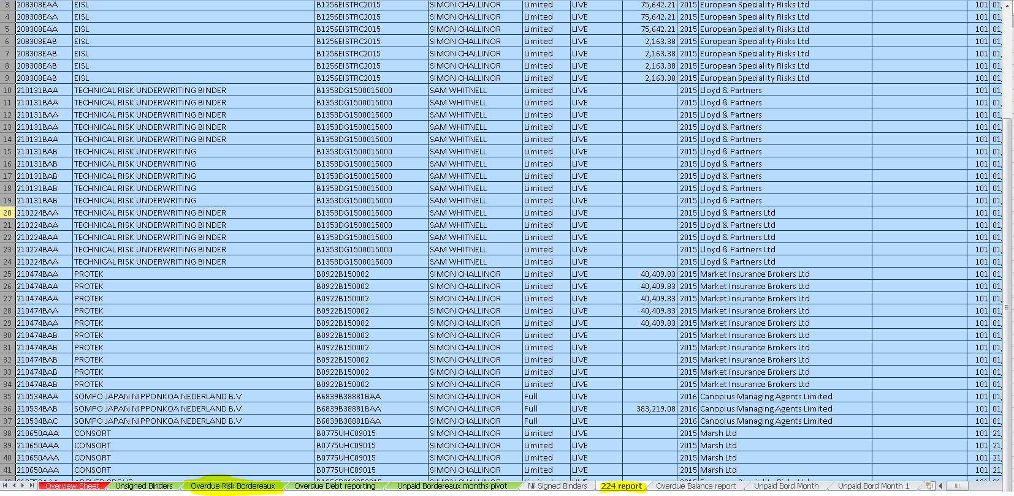

* Right click on **UW_Division** to disconnect the Slicing tool (i.e. to untick **PivotTable3, PivotTable4, PivotTable6 , PivotTable12 & PivotTable7**) & **OK** :

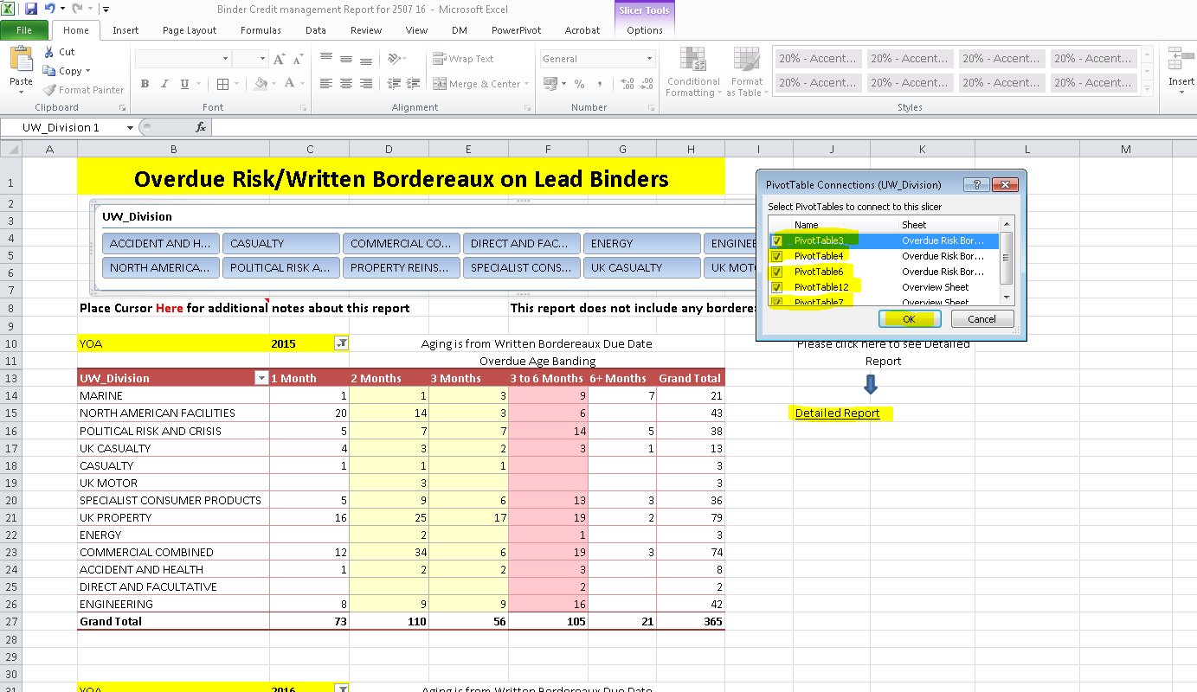

* Click on **“Detailed Report”** to disconnect the Slicing for **YOA** & **Class of Business in the same way**.
* Right click on **YOA** Slicing table to disconnect the tool (i.e. **Untick PivotTable4** only from YOA Slicing table & OK)

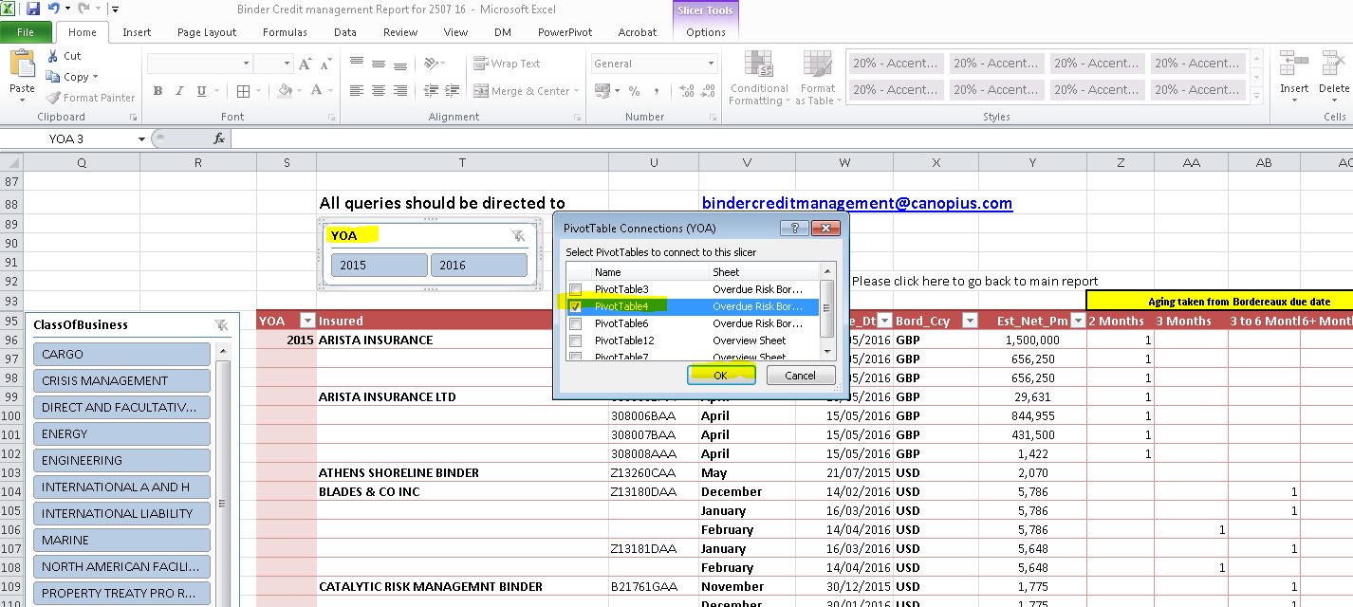

* Now right click on **ClassofBusiness** to disconnect the Slicing (i.e. to untick **PivotTable3, PivotTable4, PivotTable6 , PivotTable12 & PivotTable7**) & **OK**

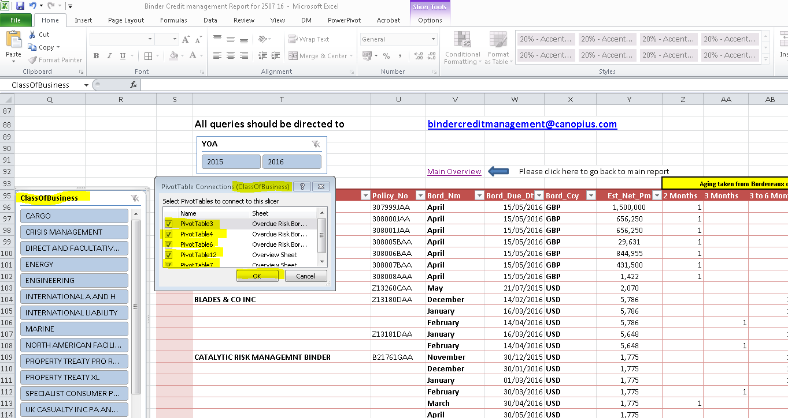

* Now click anywhere on Pivot of **Overdue Risk Bordereaux** to **Change Data source** & then click on Change Data Source :

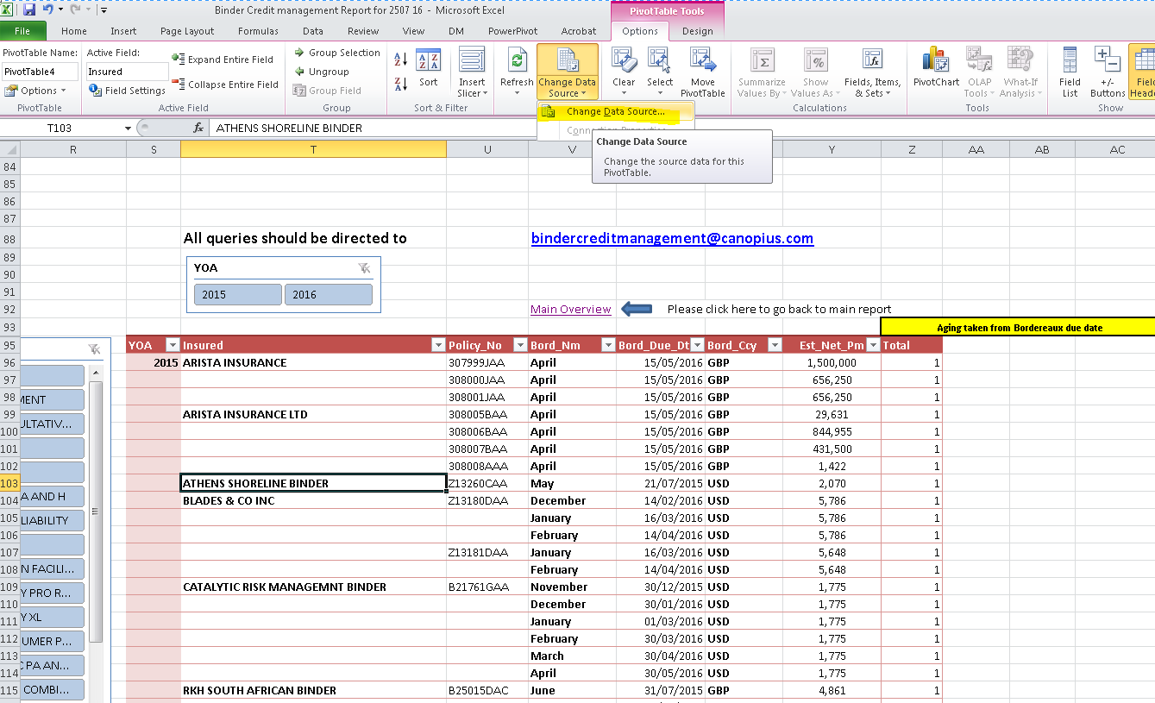

* Now Click on **A1** then Ctrl+Shift then **right arrow key**, **down arrow key** & then **OK** (To select the updated **data range** for Pivot) :

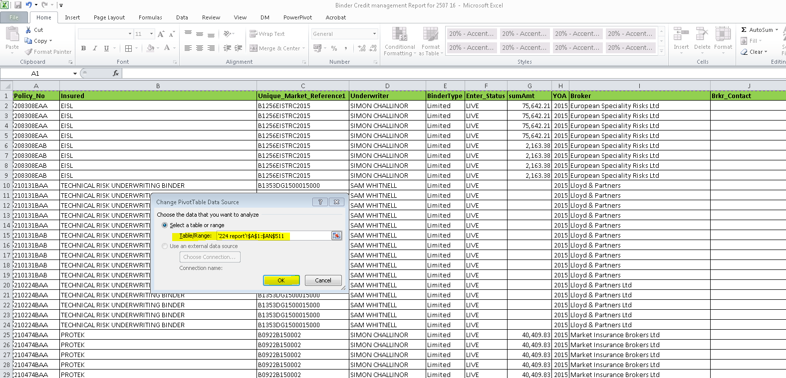

* Now click on **Refresh** button on Toolbar to Refresh the Pivot :

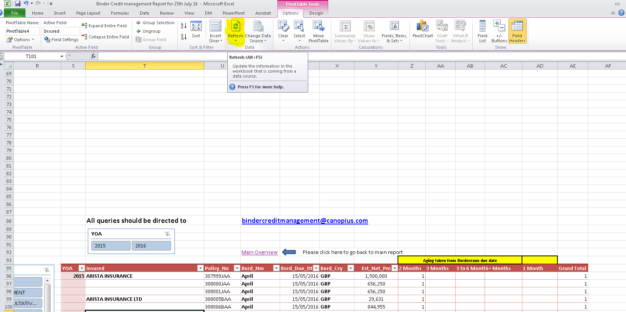

* Change the data range for Pivot on other four Pivot’s as well (i.e. On Main Overview of Overdue Risk Bordereaux report for **YOA 2015** & **YOA 2016** then in Overview Sheet **Overdue Risk/Written Bordereaux on Lead Binders** & **Criteria Chosen**)
* Make sure we refresh the Pivot after every change data source command.
* Once data range is updated go back to Slicing tools of **UW_Division** & right click on it to reconnect the Slicing tools (i.e. reconnect by Box tick on **PivotTable3, PivotTable4, PivotTable6 , PivotTable12 & PivotTable7 & OK**) :

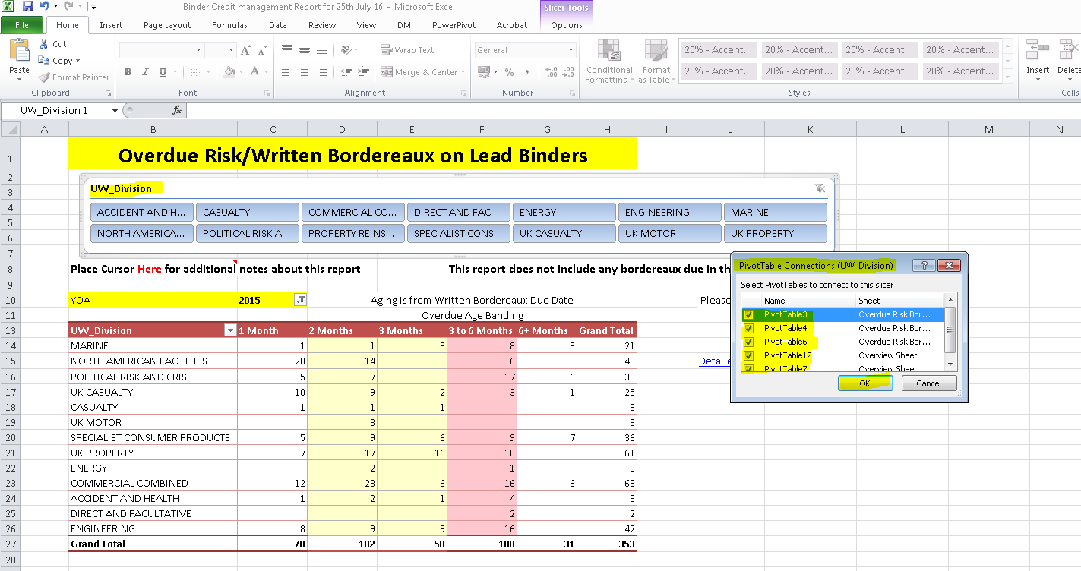

* Now perform same action for other two Slicing tools which are on **Detailed Report** Sheet :

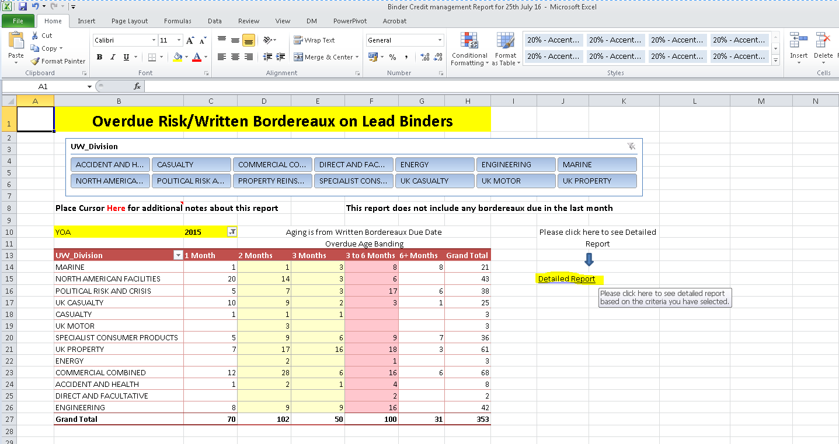

* Only one **PivotTable4** for **YOA** & Five for **ClassofBusiness** (i.e. PivotTable3, PivotTable4, PivotTable6 , PivotTable12 & PivotTable7) :

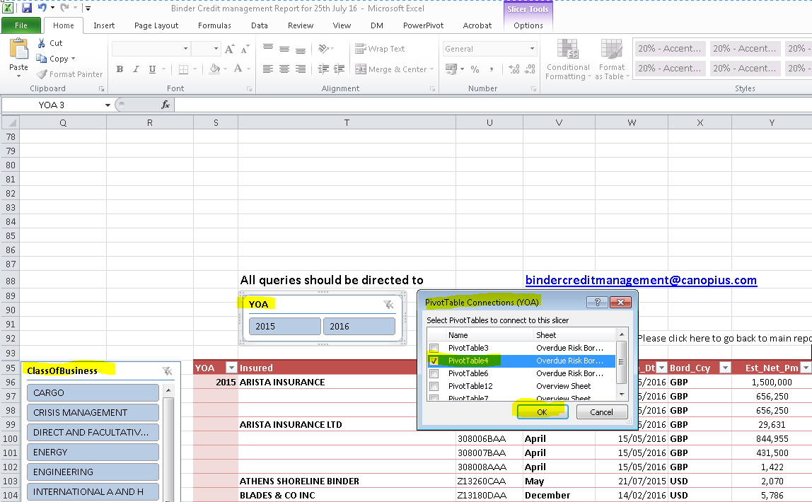

* Go back to main screen
* Check by clicking on any single risk code under **UW_Division** slicing tool in **Overdue Risk Bordereaux** to ensure all Pivot Tables shows the same figures in ‘**Overdue Risk Bordereaux**’ Tab, Overview’ tab and also that under Detailed Report we have the correct number of lines that is showing as o/s under the Overdue Risk bordereaux and Overview sheet.

**Overdue Debt Weekly Report (see last page for when preparing Monthend Reporting)**

This report is run from the RS029 in Deman to highlight the overdue debt per policy.

* Expand all rows to fit data.
* Right click to reduce column width of column **BC** to **15** :

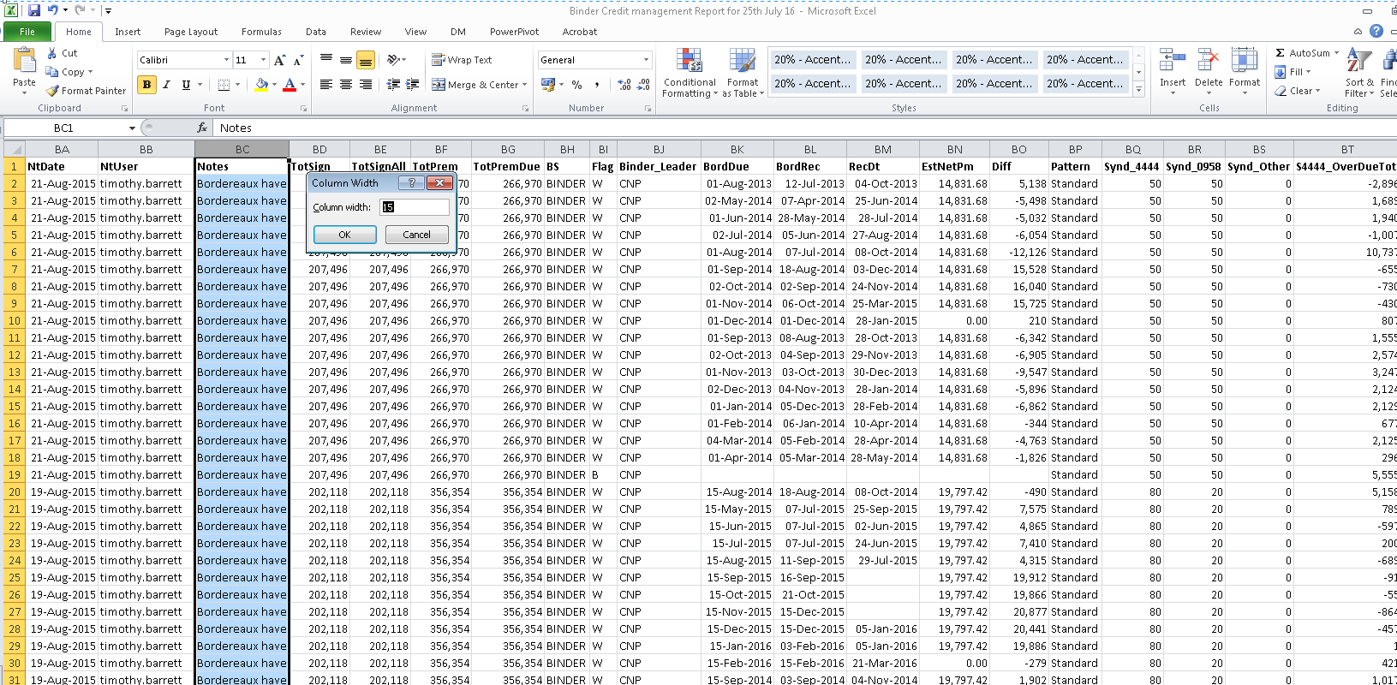

* Apply filter & delete all lines the from **Flag** column BI except **“W”**

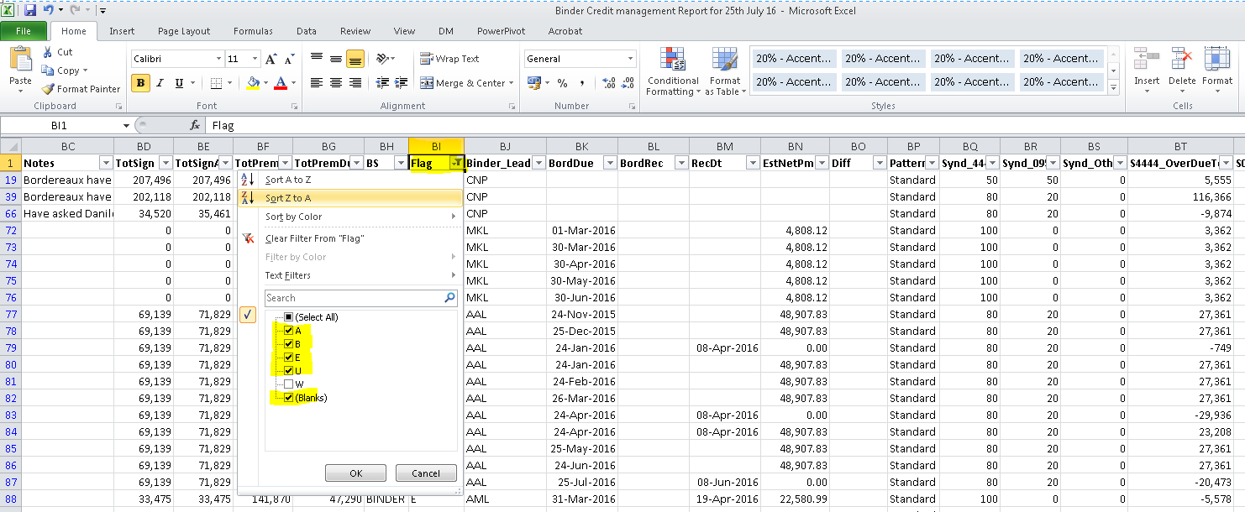

* Sort by **Year of Account**, Column B, and keep 2014/2015/2016/2017 years only (need to delete **2011, 2012 & 2013**) :

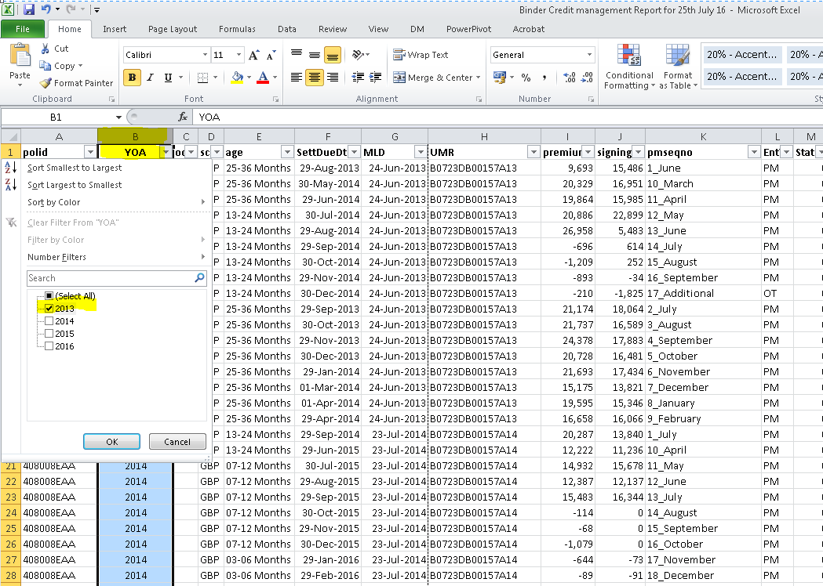

* Sort by "Pattern" and remove "**Mixed**" Column **BP**.

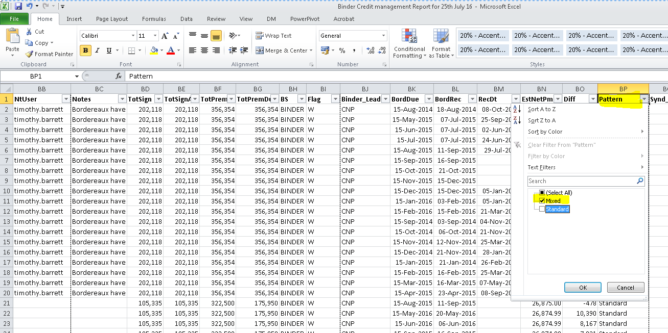

* Delete all lines where the difference is **less than 5,000** units (i.e. from debits + credits) Column **AU (TotalOd)** :

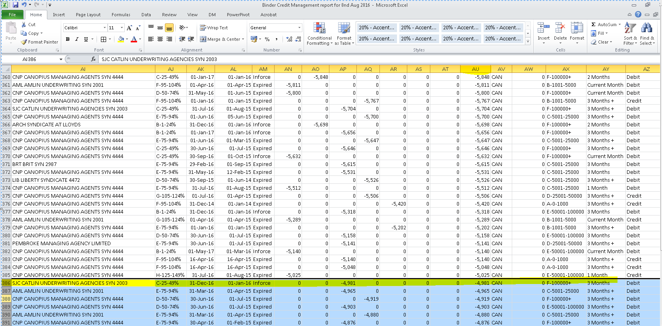

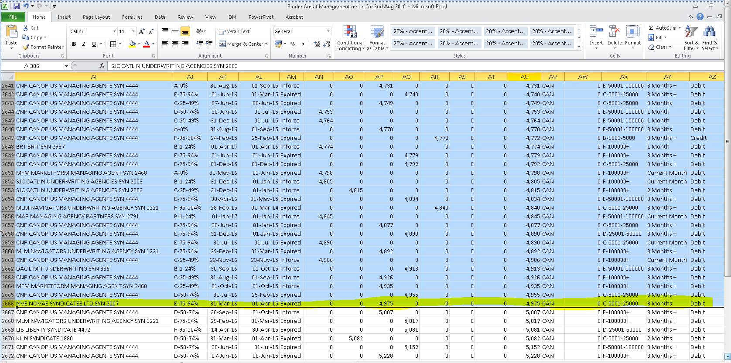

* Remove all **fee and/or Profit commission lines** from **column K** (There should not be any, but if any are there, send it to Binder Credit Manager but before sending it to Binder Credit Manager we check the lines first in Deman to make sure they are in fact Fees or PC if not move the same to correct line & update the same in report)

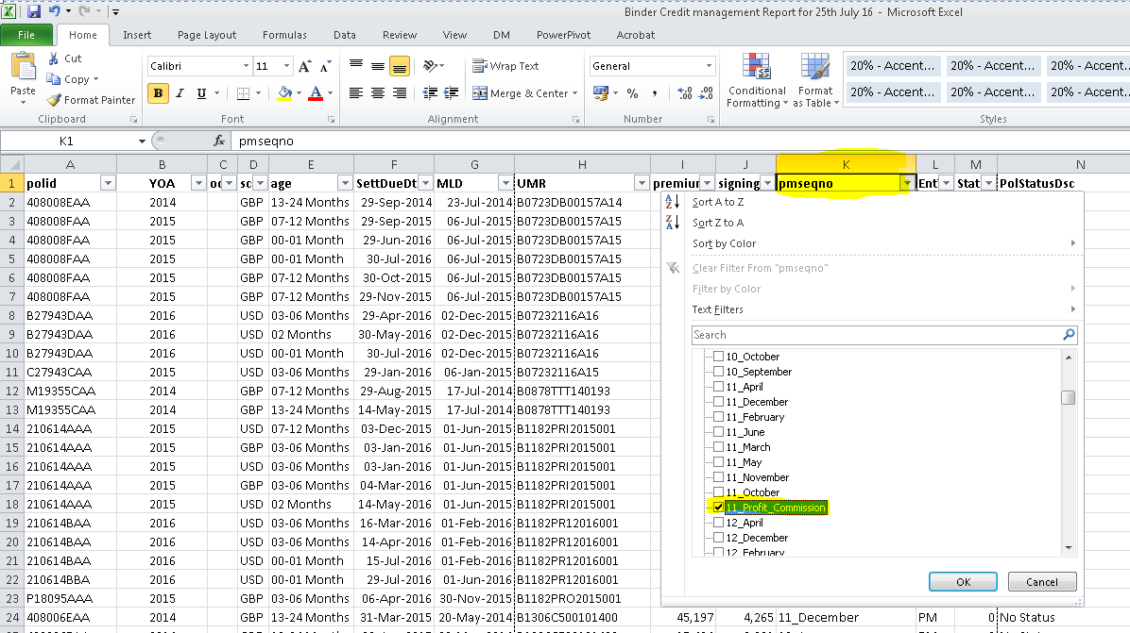

* Add in a column to the right of Broker Name (Column U), head it up as "**Direct or Non Direct**".

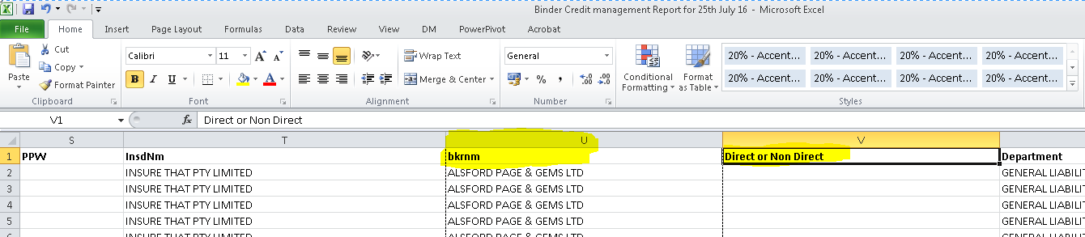

* Now sort by **broker name** and then add Non Direct next to all the lines and then just change the **Canopius Managing Agency** ones to show **Direct**

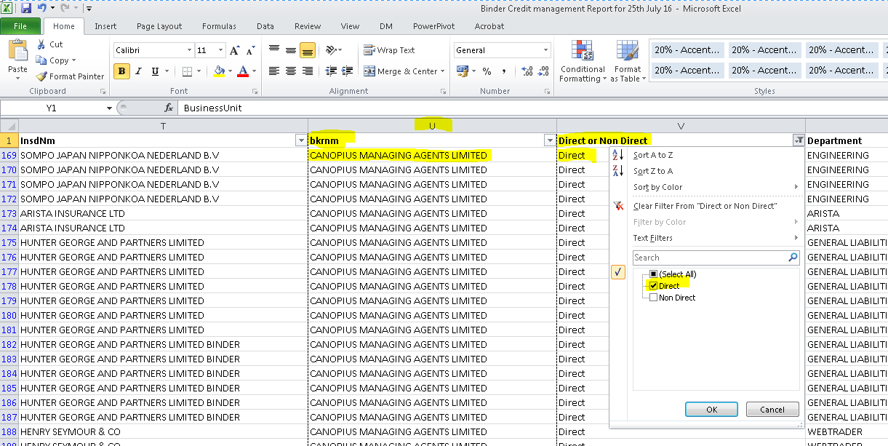

* Take the Filters Off

[Note: Makes sure both the new data and new report are opened under same Excel as won't work if two are opened in separate sessions.]

* Delete the existing data under "**Overdue Balance report**” and paste in the new data.

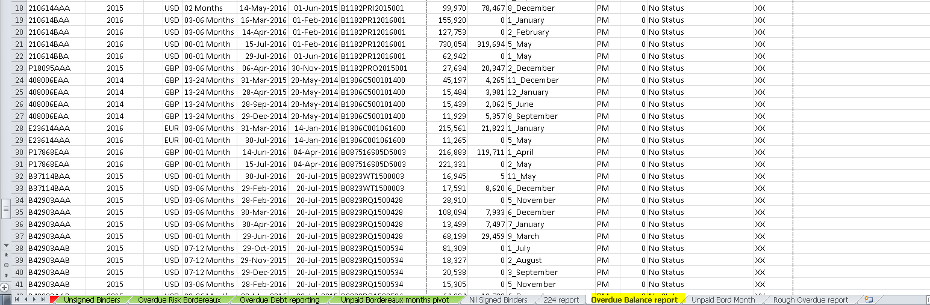

Delete the tab where you have just copied the data from.

* Now disconnect the Pivot tables under “Overdue Debt Reporting tab” from the slicing tools “**Underwriting Division Criteria**”, “**Year of Account**” & “**Age2**”. Then click on **Detailed report** :

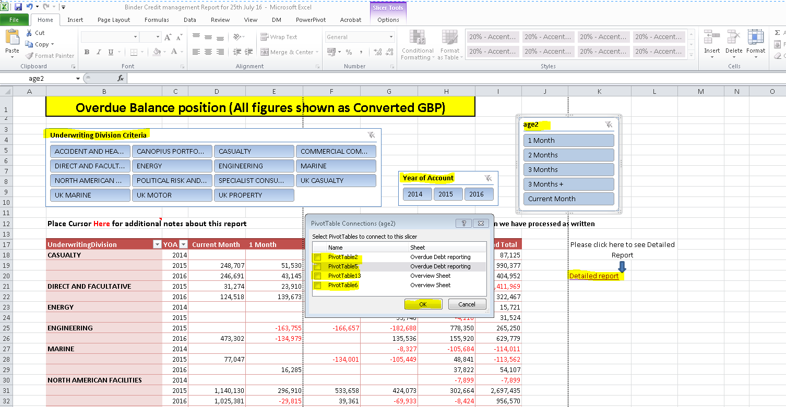

* This will take to detailed report sheet (shown below) where you need to disconnect the Pivot table in Slicing tools for “**subclass**” :

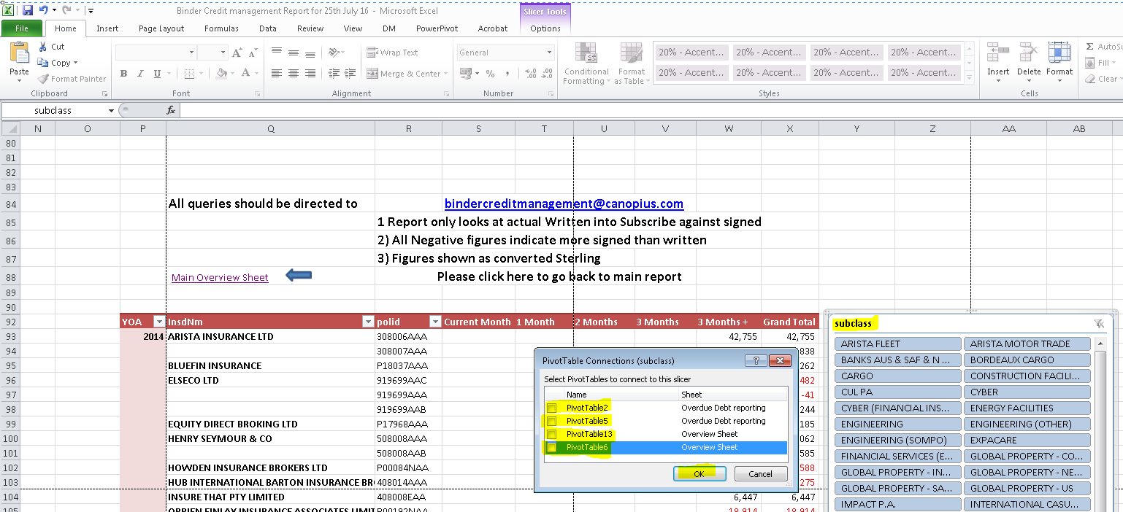

* Then click on all the Pivot tables & change the data sources for all Pivot including the two Pivots which are on the Overview sheet as well.

[Note: Don’t forget to refresh the Pivot after every Change data source of Pivot.]

* After updating all pivot tables, reconnect using the Slicing tools for “**Underwriting Division Criteria**”, “**Year of Account**”, “**Age2**” & “**subclass**”.
* Check by clicking on any single Division in ‘Overdue Debt reporting’ tab to ensure all Pivot Tables shows the same figures in ‘Overdue Debt reporting’ Tab & ‘Overview’ tab.
* If data reflects correctly after check then save the file.

**Unpaid Bordereaux months Report**

This report is run from Deman to highlight all Unpaid Bordereaux.

* Copy & paste the exported data to **Unpaid Bord Month 1.**
* Enlarge all columns.
* Close the export copy once the data has been copied across.
* Add filter and filter on Colum H “Signings” tab in smallest to largest view.
* Delete all lines where Column G is blank or 0.00 and there are signings shown in column H.
* Remember that there are Negatives as well as Positives so filter on Nil values (Untick the nil value so that all negative and positive figures show). Delete these so that only the lines are shown with Nil signings.
* Now insert **three columns** to the right of column **C (Due Date)** :

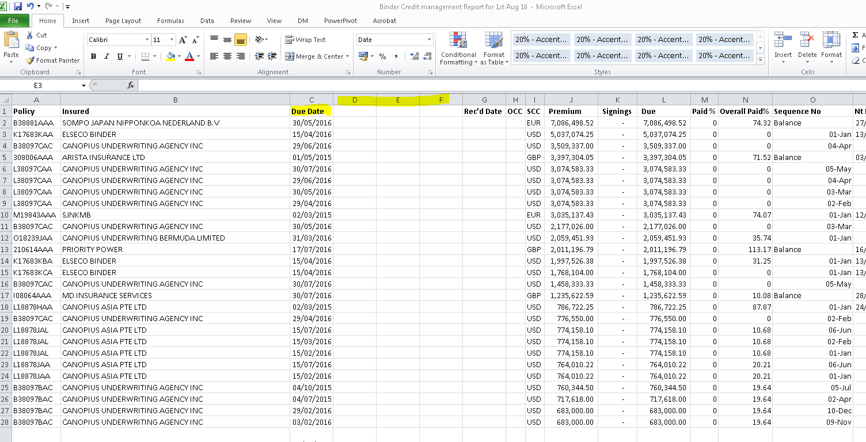

* Copy the headings formulas for **“Aged Month + Rounded + Age Period”** from **existing report** i.e. Colum **“D + E + F”**. *(Note that the formula should be copied by right click)*.

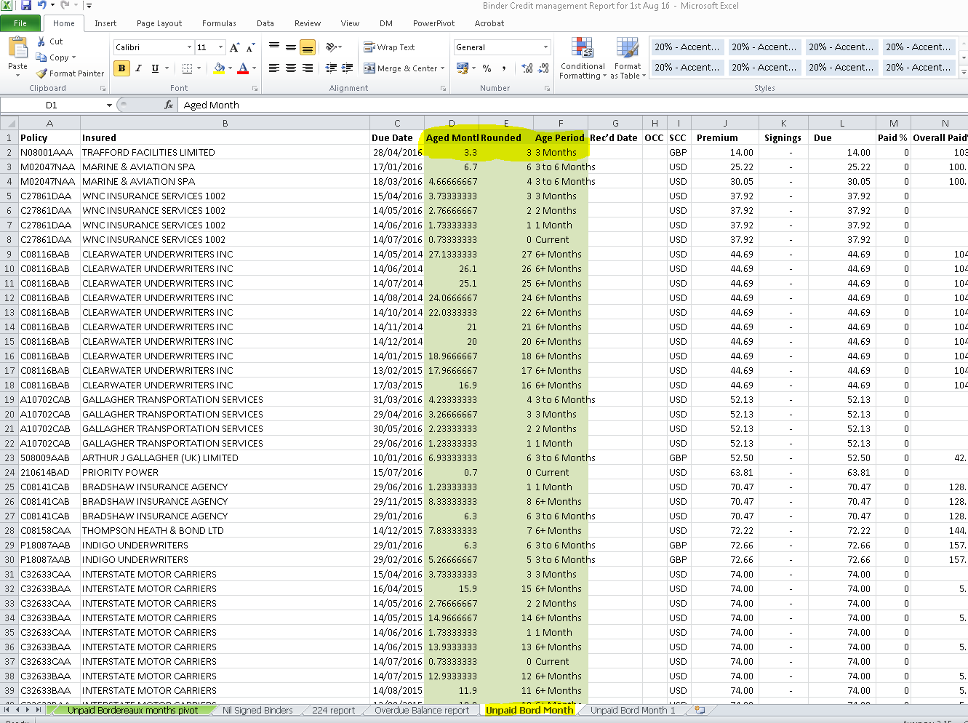

* Now paste the formulas in **Unpaid Bord Month 1** where you have inserted **three Columns** :

*[Note : Ensure all three columns are formatted as General]*

(Formula should be **pasted via tool bar button click** to ensure data get paste along with Formulas)

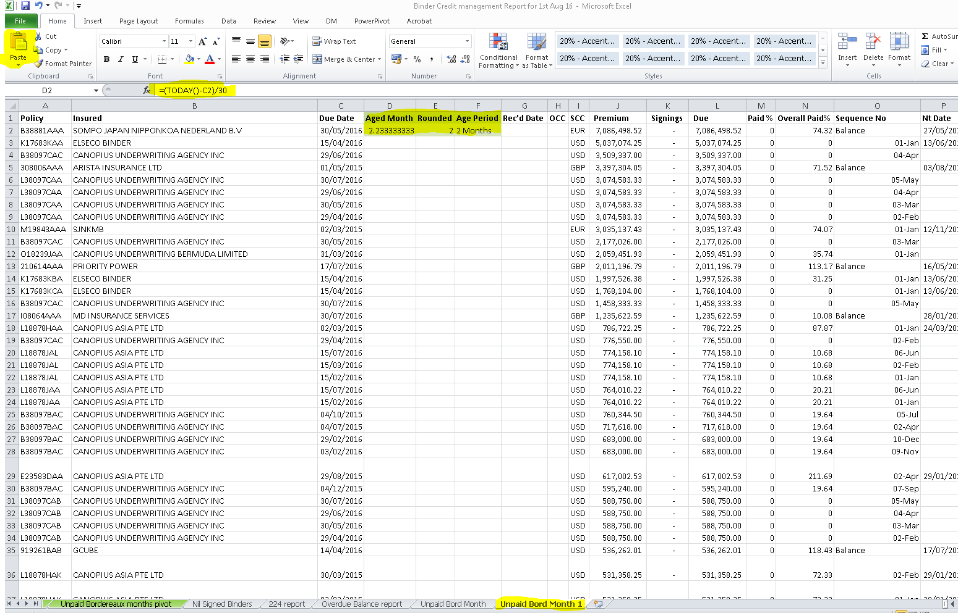

* Copy the formulas down by double click(Select cells D2+E2+F2 & double click at the bottom right of F2)
* Amend Column Q (Notes) to width of 15.
* Add filters & filter Column O in order. Delete **Additional & Balance rows**.

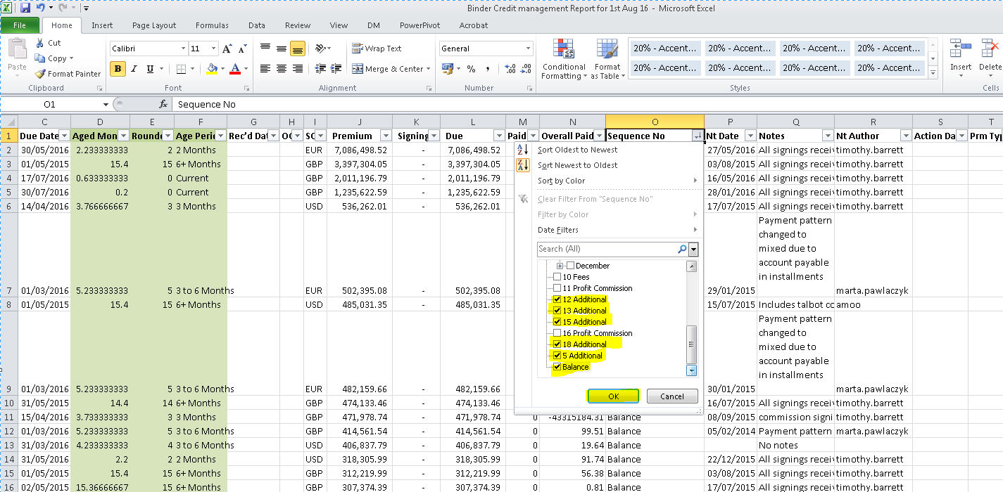

* Change **Column O** to **Custom** **DD-MMM**.

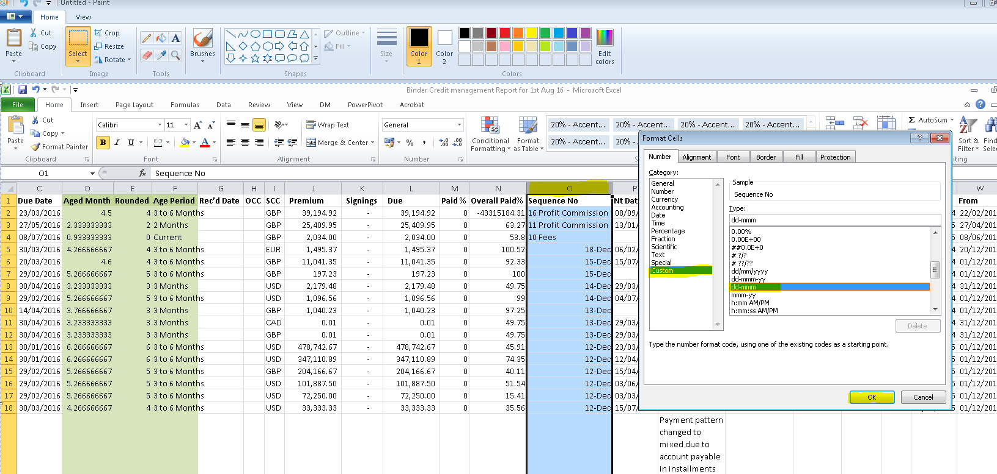

* Enter **three columns** to the right of column **O (Sequence No)** :

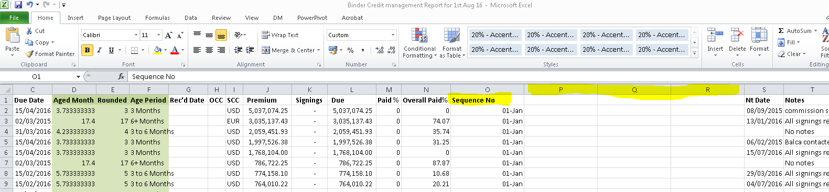

* Now copy the formulas for **“Text + Sequence No + Month”** from **existing report** i.e. Colum **“P + Q + R”**. *(Note that the formula should be copied by right click)*.

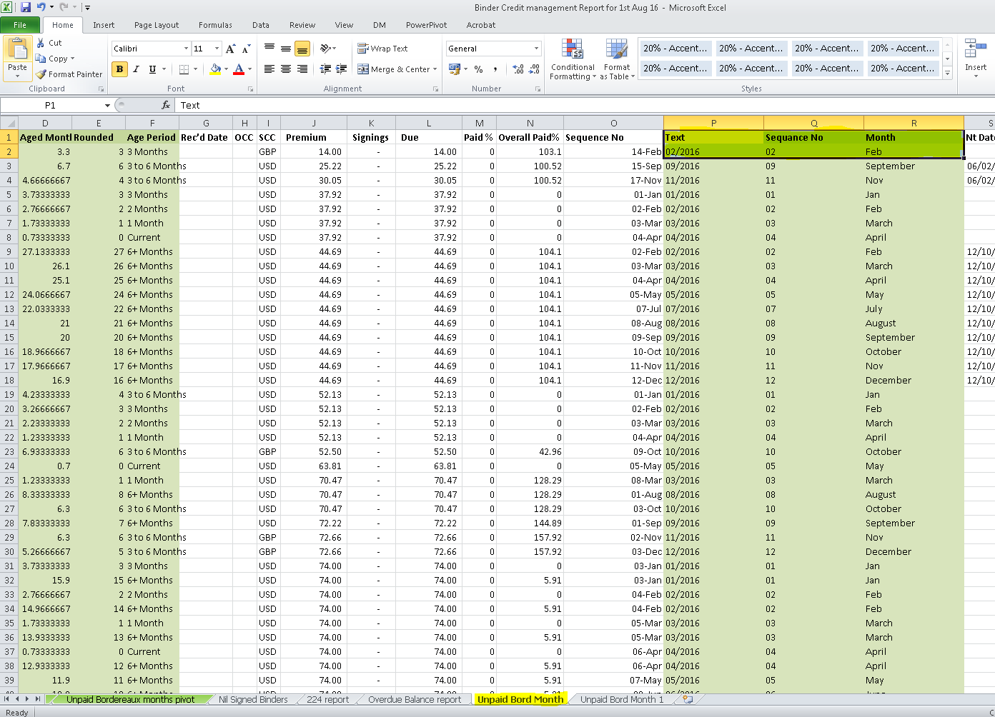

* Copy the formulas down by double click. (Select cells P2+Q2+R2 & double click at the bottom right of F2)
* Filter on Column L & arrange in **Smallest to Largest**.

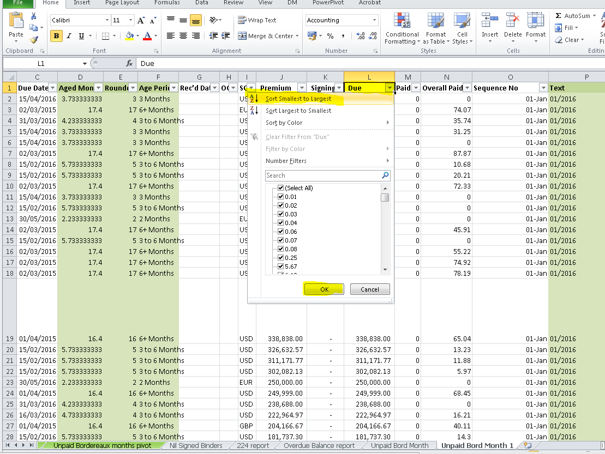

* Delete all the lines where the **Due** amount **is less than 10 units**.

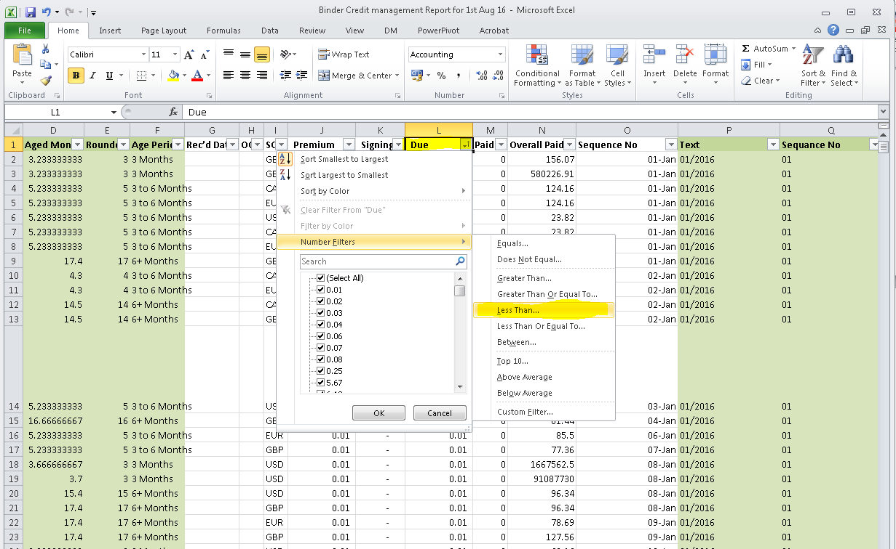

* Remove the filters.
* Remove the Slicing tools **connections** for **Division , YOA , Lead & Age Period**

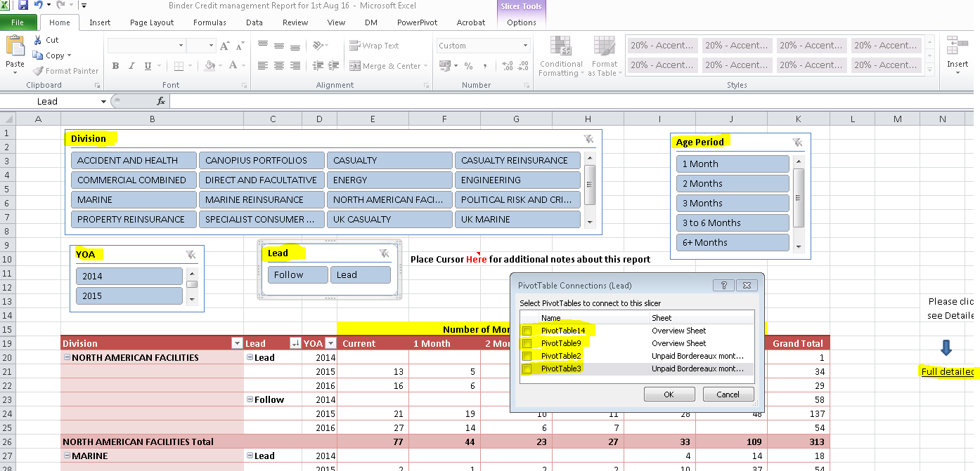

* Then click on **Full detailed report based on Criteria chosen** to remove the connection for COB Slicing tools:

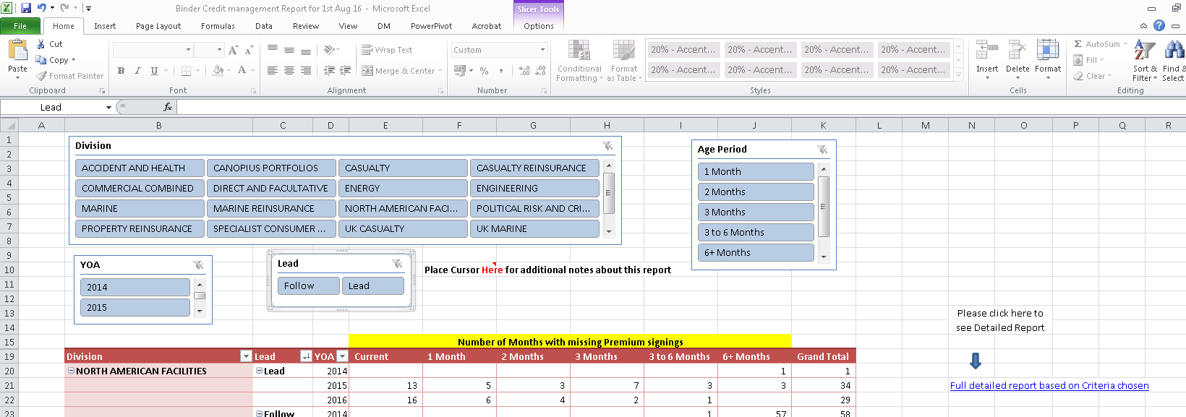

* Change the data source for all the pivots & refresh pivot after every data change (i.e. on sheet **Unpaid Bordereaux months pivot** & on **Overview Sheet**).

[**Note that source will be the new data which you have set up and formatted in the new sheet/tab. When you open up Options and Change data source it will automatically show the existing data sheet so you will need to click on the new Tab and highlight the data.**

* Once the data source is updated as per new data then reconnect all the Pivot tables.
* Check by clicking on any single Division in ‘**Unpaid Bordereaux months pivot**’ Slicing tools to ensure all Pivot Tables show the same figures in ‘**Unpaid Bordereaux months pivot**’’ Tab & ‘**Overview Sheet**’ Sheet.
* Remember to delete the old data sheet from current file if not completed already
* And save the file.

Before sending report to underwriters, make sure that all tab “Overview Sheet” ,” Unsigned Binders” ,” Overdue Risk Bordereaux” ,” Overdue Debt reporting” and “Unpaid Bordereaux months pivot” Should have months in sequence like(Current Months,1Months,2Months,3Months,3 to 6Months,6+Months).If these months are not in sequence then we have to drag them manually to the correct sequence.

E.g.: Months are not in correct sequence as below:

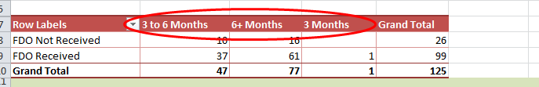

So, we have to correct it manually as below:

1) Select the month which is in wrong sequence

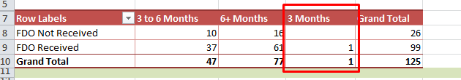

2) Then drag it to the correct sequence month and it will appear as below:

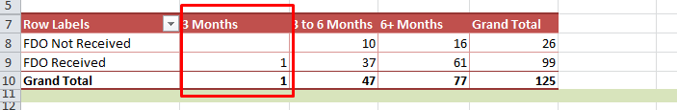

**Binder Credit Manager suggested the following process:**

* 1. All slicing tools work and the pivots change
  2. By clicking on NAF on each tab that the Summary sheet changes
  3. The aged columns are all in order
  4. The detailed analysis has changed depending on the criteria chosen
  5. The detailed sheets have all the data (Insured etc..) and the overall totals shown agree to the summary tabs
  6. Check the report RS029 used for preparation of 3rd tab for **monthend** report used from the below path & for current month (YYYY_MM_DD) :**H:\Jim\Premium Credit Control\RS029_Reports**
  7. Check the deleted data from report where in all fee and PC line should be checked for signings auto allocated by system to that line, if allocation is not correct then move signings accordingly to the correct line